AWS Internship | October 01 to October 31  2026
This project focuses on implementing Cross-Region VPC Peering using Amazon Web Services (AWS).It establishes secure private communication between two Virtual Private Clouds (VPCs) located in different AWS regions.The project involves configuring VPCs, subnets, EC2 instances, route tables, and peering connections.It enables communication between cloud resources using private IP addresses without requiring public internet routing.The main objective is to gain practical knowledge of AWS cloud networking, connectivity, and network security.

DAY 1
Cloud Analogy: Electricity & Vehicle Rental
Cloud computing follows an utility model similar to electricity: you consume and pay for power only when you need it, rather than building and maintaining your own power station.

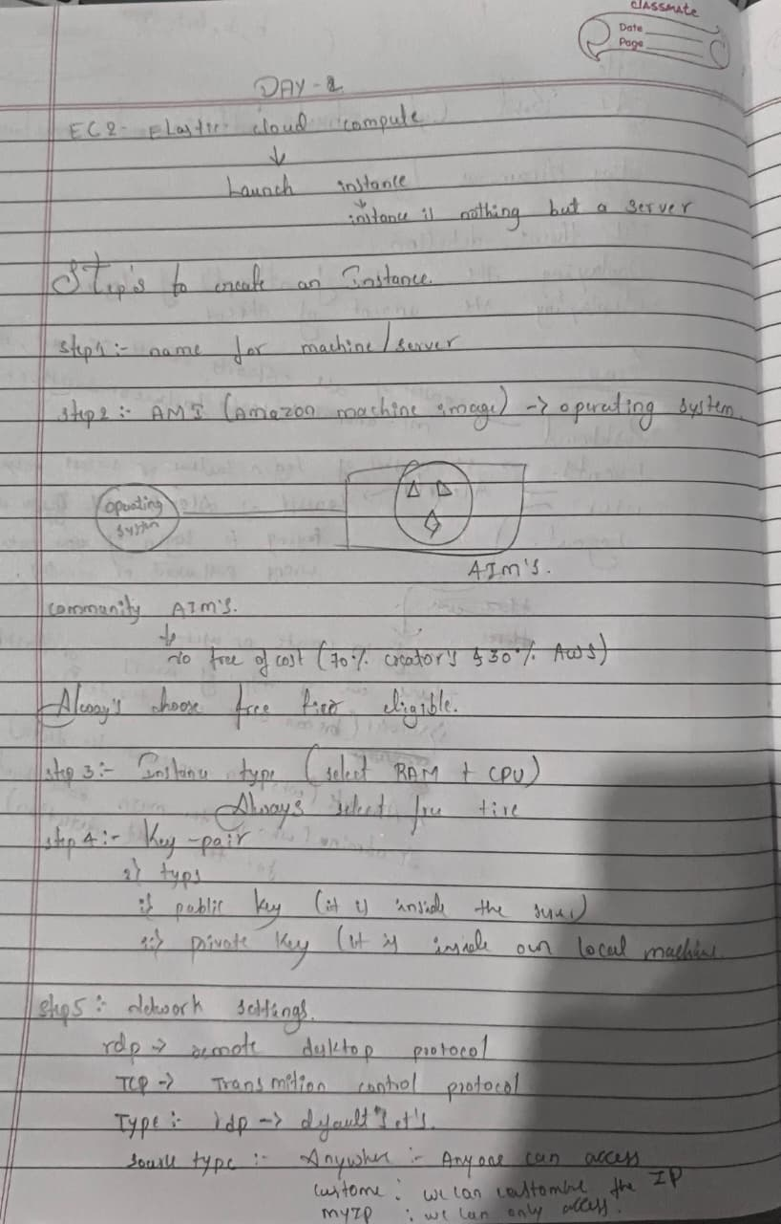

DAY 2 of AW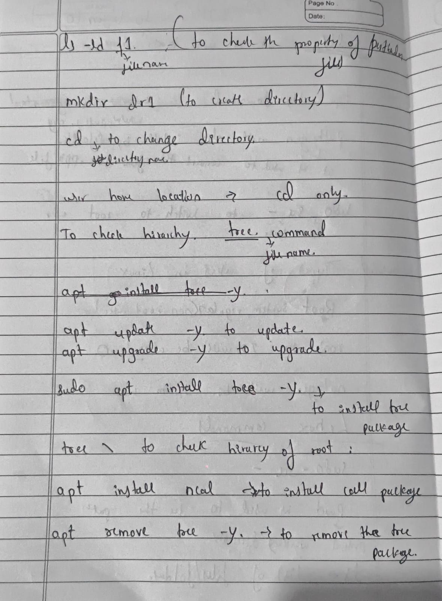

Day 3 of AWS

Creating the instances in Linux operating System and also creating the instances using the bootstrap script to print the output directly on to the html

Creating the instances

- Naming the instance
Naming the instance with a proper name (Linux-WebServer)
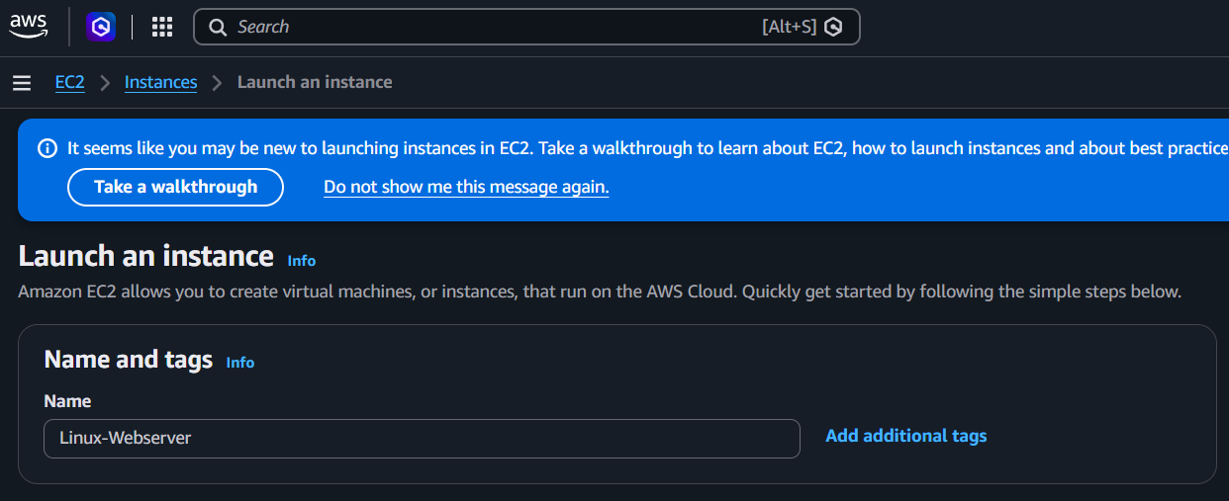

- Selecting the operating System
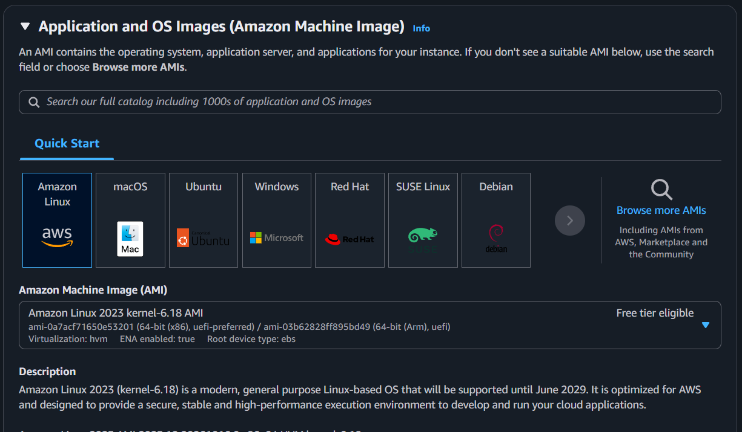

- Creating the Key-Pair values
Creating a new Key-Pair Value as Linux-WebServer

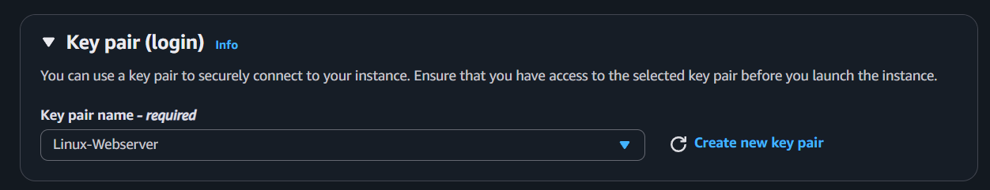

- Network Setting

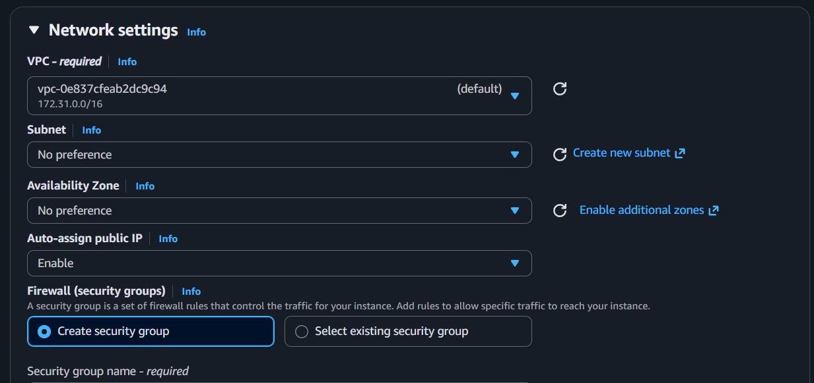

- Security Setting
Naming the Discription As Linus-WebServer
Also set the security group as ssh and source type as My IP to acsses the content in your IP Adress
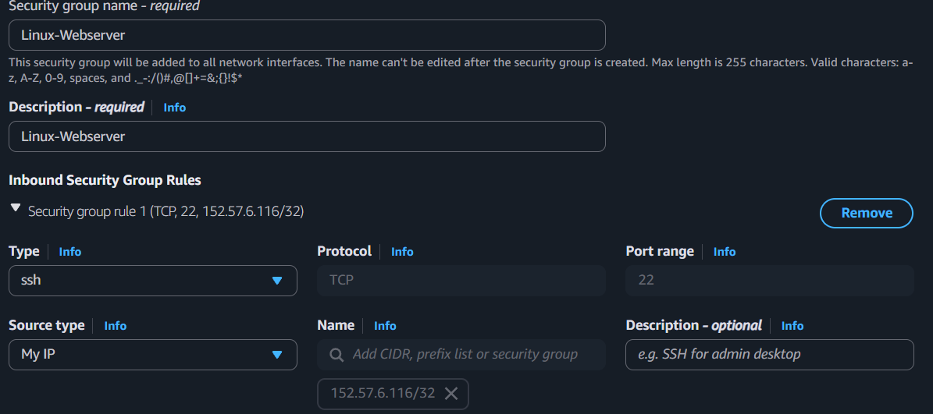

- Creating another security group

Here the security group will be HTTP and source type will be Anywhere (to acess the content from any where or it is a public IP)

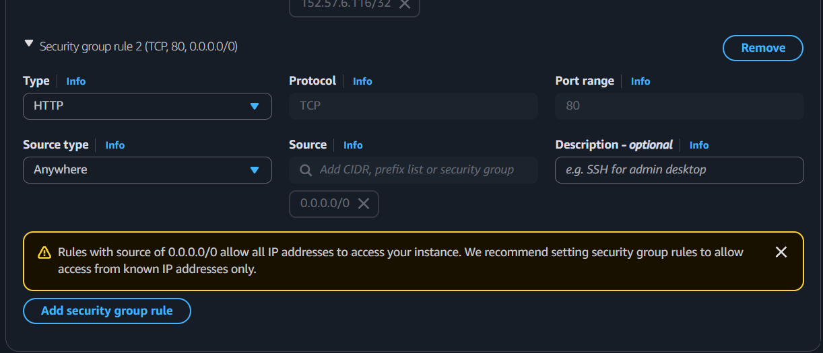

- Launching the instance
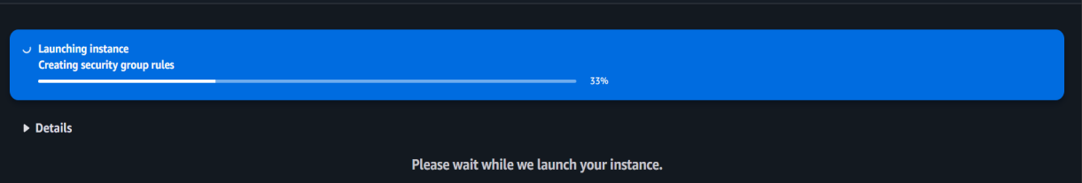

There are many ways to Run the Instances like we can Run the instances using the putty,MobaXtream and others

DAY 4 of AWS

Running the instance inside the MobaXterm

When we download and install the MobaXterm inside that we can see so many options inside that the session is used the login to our instance
When we click on that session button we can see :
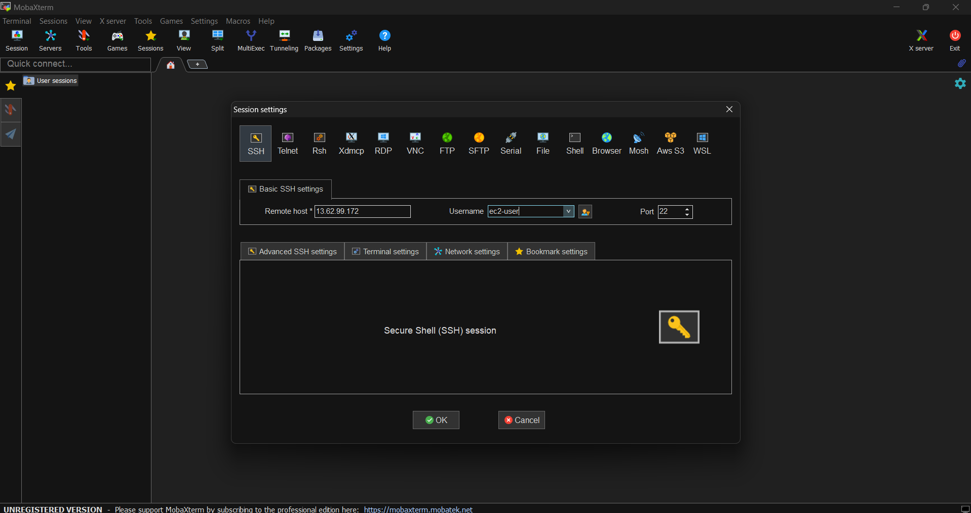

Here we can see the Remote host option where we have fill the public IP Address And in user name we should fill the Respected user name of the instance

Then click on the advanced SSH setting there we have to upload the private key file :
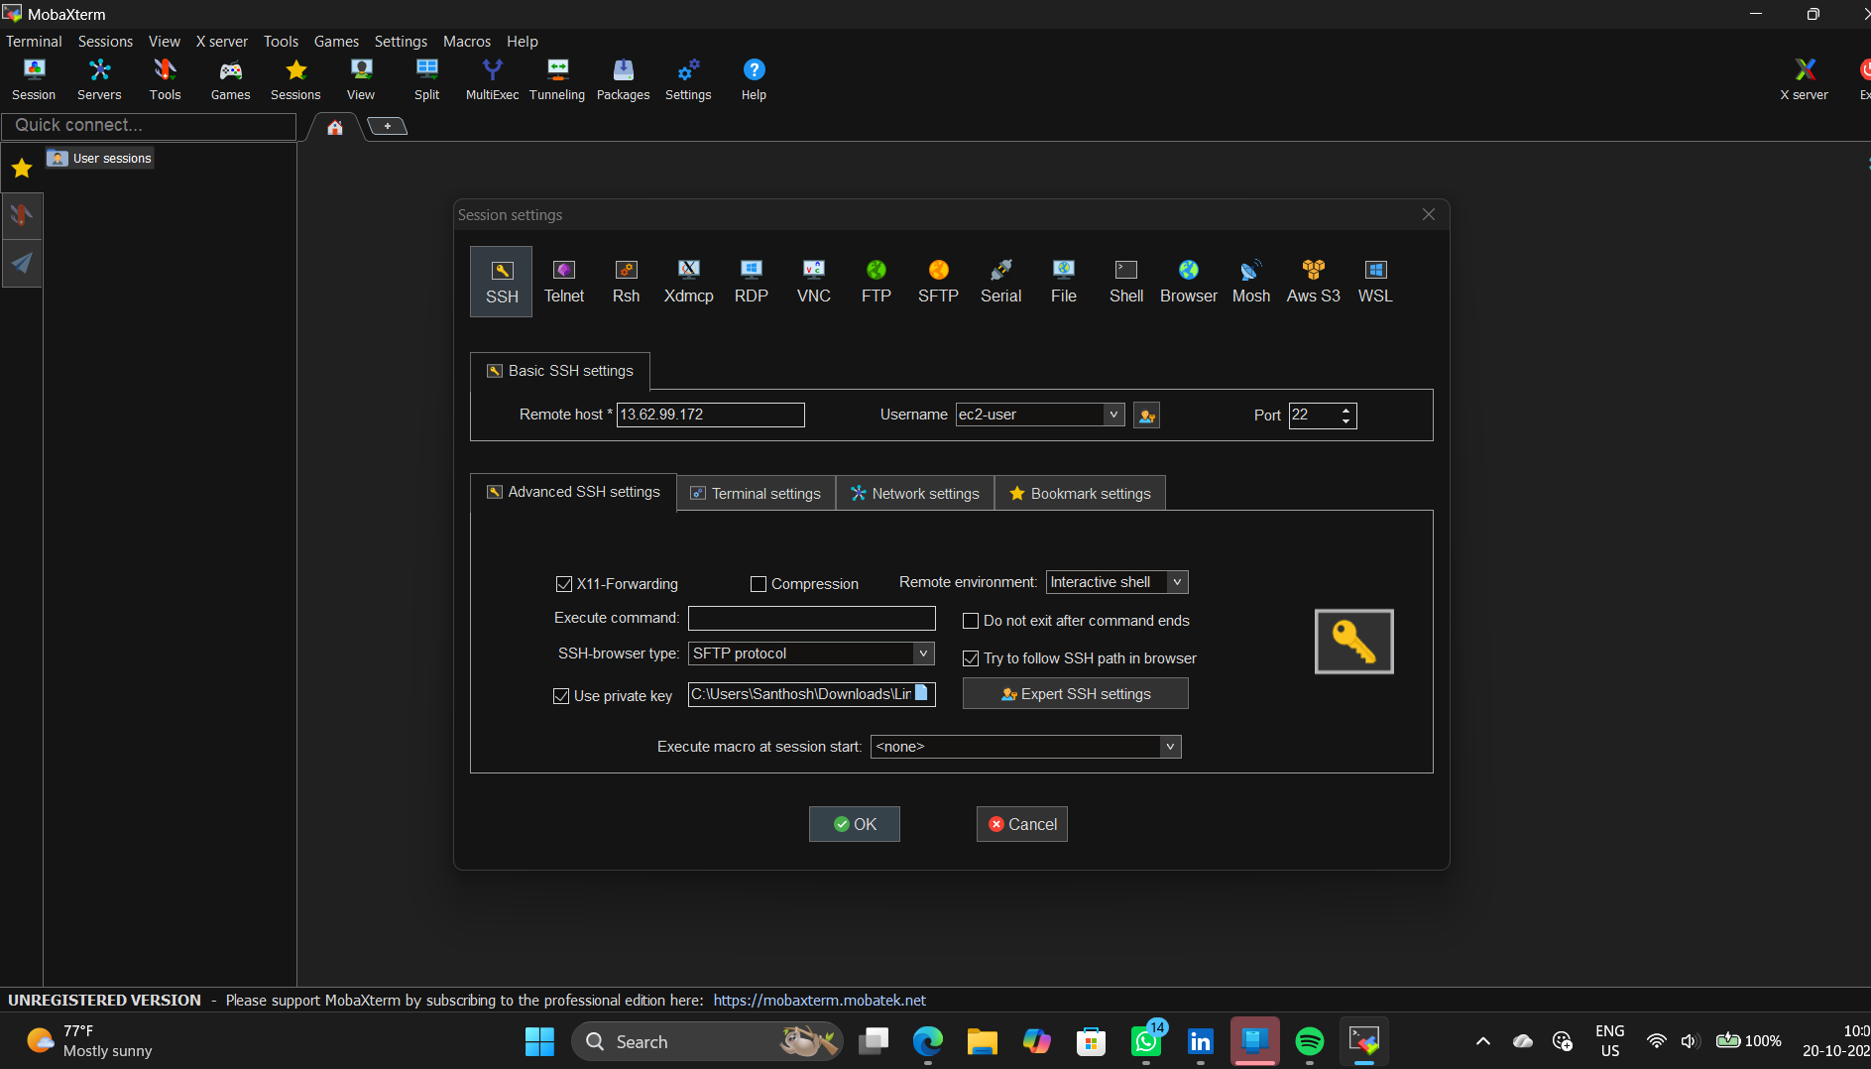

Commands which are used in the MobaXterm terminal :

- sudo dnf update –y : Updates the installed packages to their latest available versions.
- sudo dnf install httpd –y : Installs the Apache HTTP web server.
- cd /var/www/html : Changes the current directory to the default Apache website folder.
- pwd : Displays the present working directory.
- sudo su : Switches to the root user, providing administrator privileges.
- echo “Welcome to AWS Internship” : Displays the given text in the terminal.
- server httpd start : This is not a standard command on most Linux systems. Use systemctl start httpd to start Apache.
- server chkconfig on : This is not a standard command. Use systemctl enable httpd to enable Apache at startup.
- systemctl start httpd : Starts the Apache web server immediately.
- systemctl enable httpd : Configures Apache to start automatically when the system boots.
- systemctl status httpd : Displays the current status of the Apache web server.
- history : Displays previously executed commands in the terminal.
- cat index.html : Displays the contents of the index.html file.

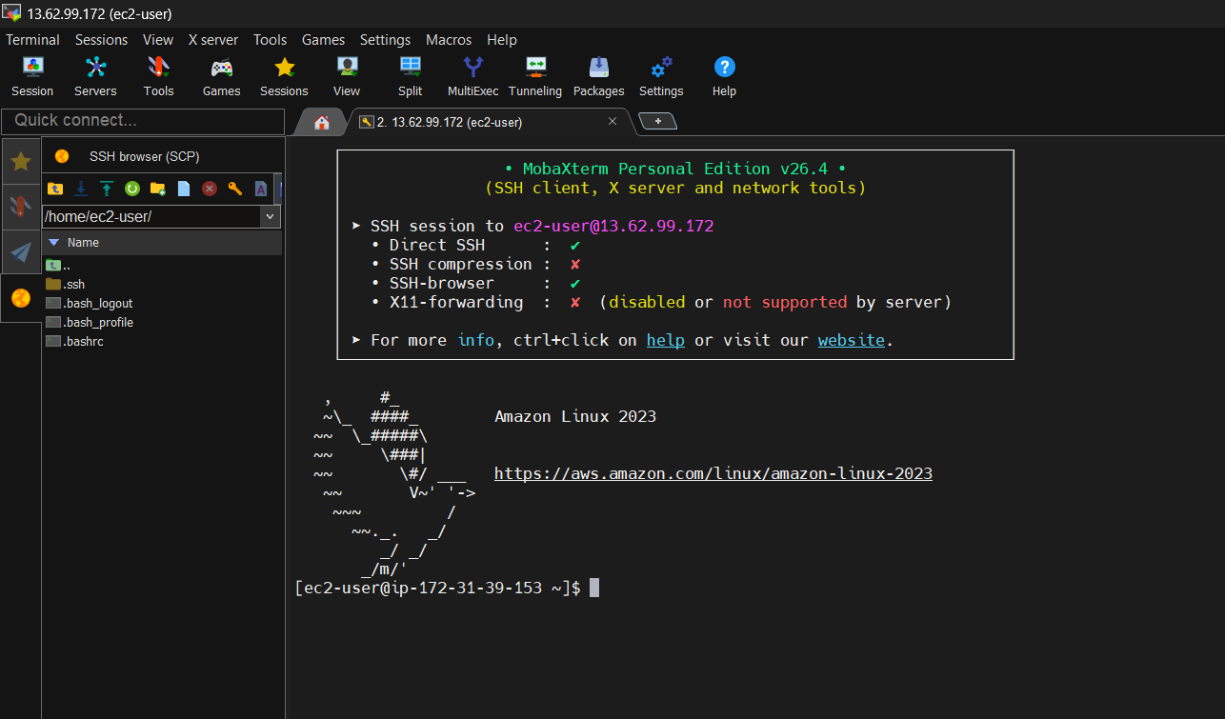

OutPut:
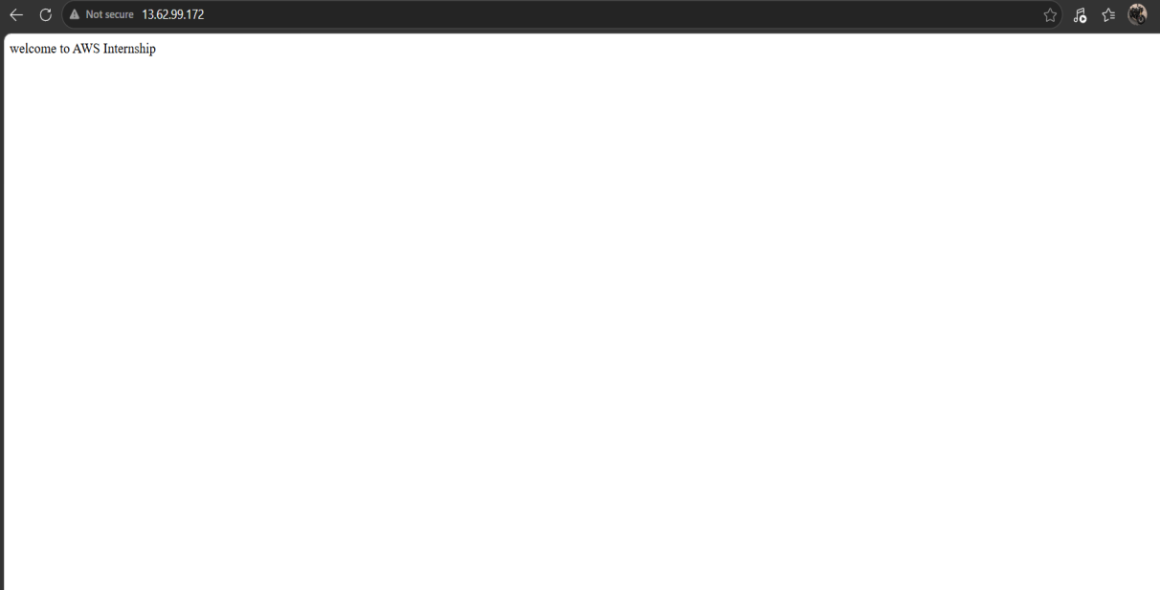

Creating the Instance for BootStrap script :

Follow the same rules as we done in the creation of Linux-WebServer
But there is only one extra step in the Aditional section that we have add the BootStrap script Either we can add the file or we can write the Script manually as shown below:
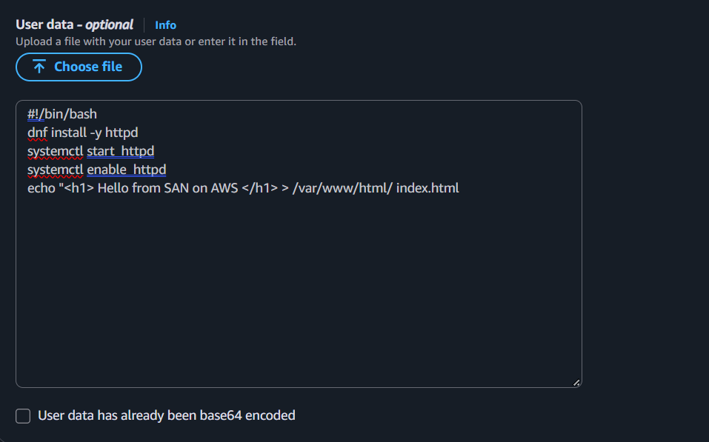

When we copy the IP Adress and run that in any browser we can see the Output as :
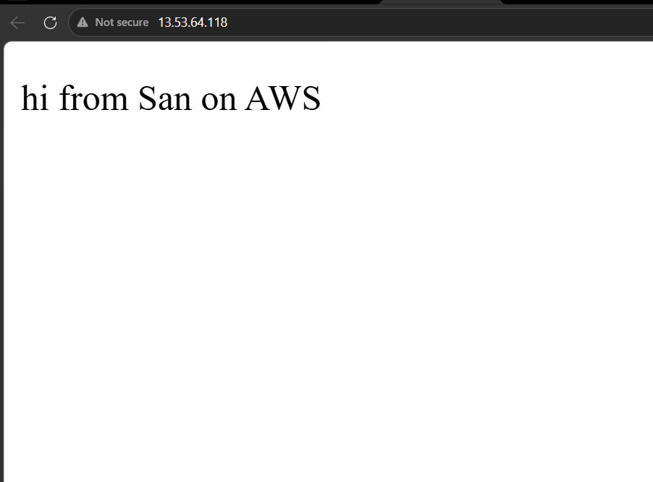

Day 5 AWS

Elastic IP, Web Server Management & Core Cloud Architecture

AWS Elastic IP (EIP) Architecture
By default, when an EC2 instance is stopped and restarted, AWS dynamically reassigns a new public IP address.
For production web applications mapped to domain names (e.g., DNS records), dynamic changes break connectivity and cause downtime.

Create the instance named as Demo-instance

Then go to the Elastic IP Address and select the instance which you want to make it as a static IP Address as shown Below:

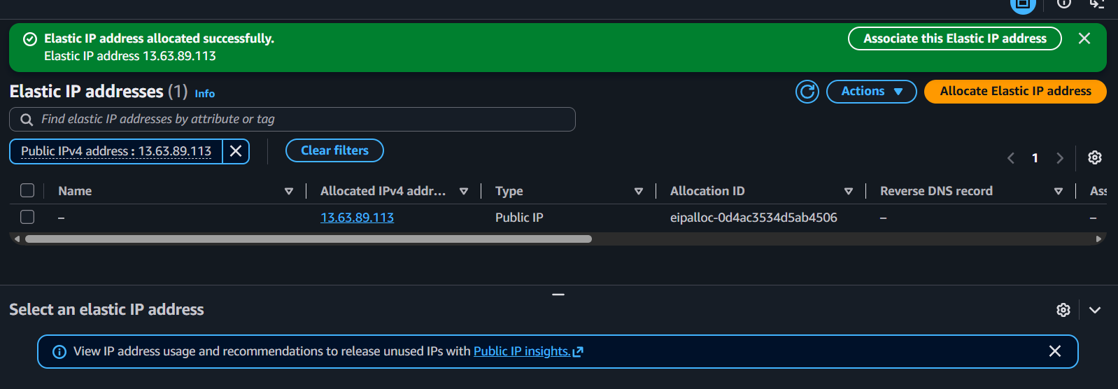

Then go to Actions there you can see the option called Associate Elastic IP Address just click on it to make instance IP Address as static

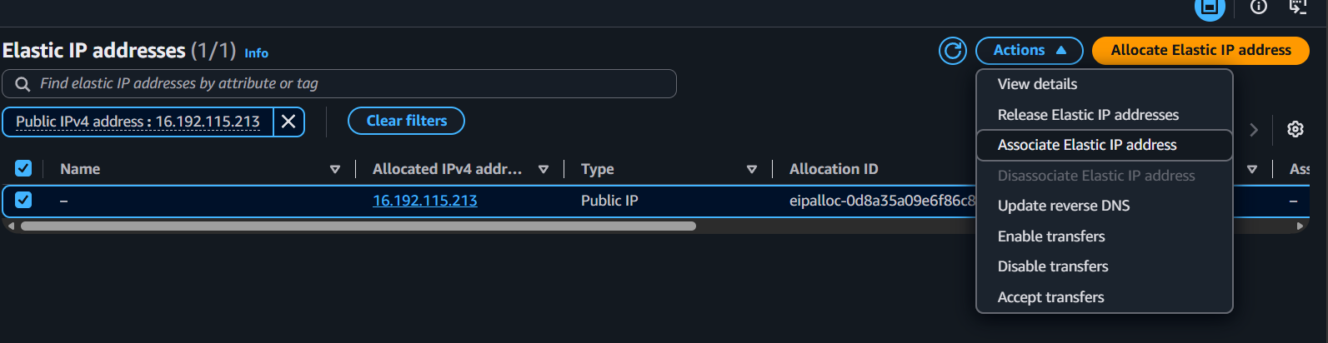

After you can see the Public IP Adress as been changed :

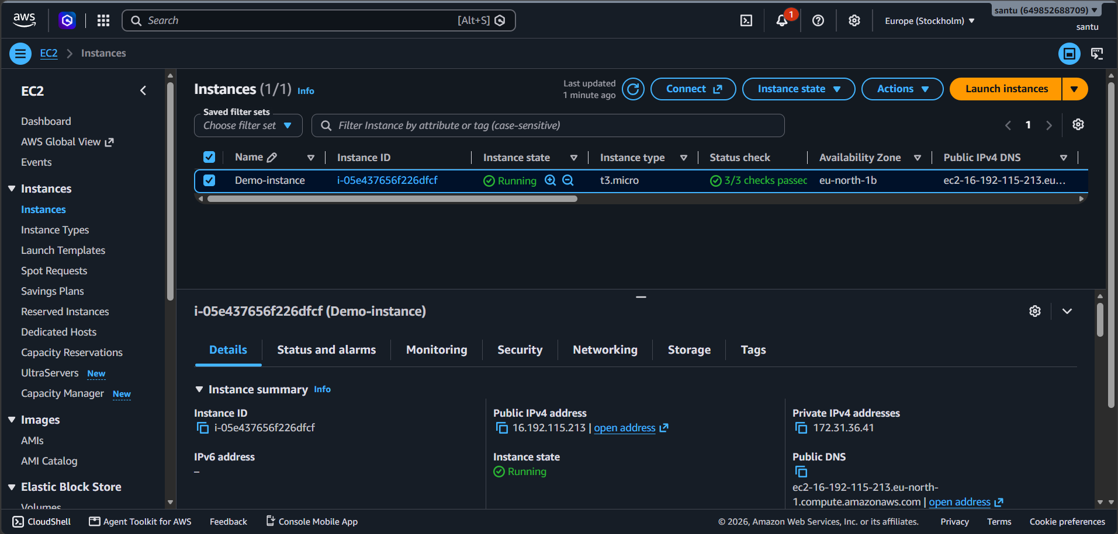

After this Before Deleting the instance first we have release the Elastic IP Address so that there are no extra charges from the AWS
Before Releasing the Elastic IP Address first we have to Dislocate the Elasic IP Address then only we can Release the Ekastic IP Address

Dislocating the IP Address
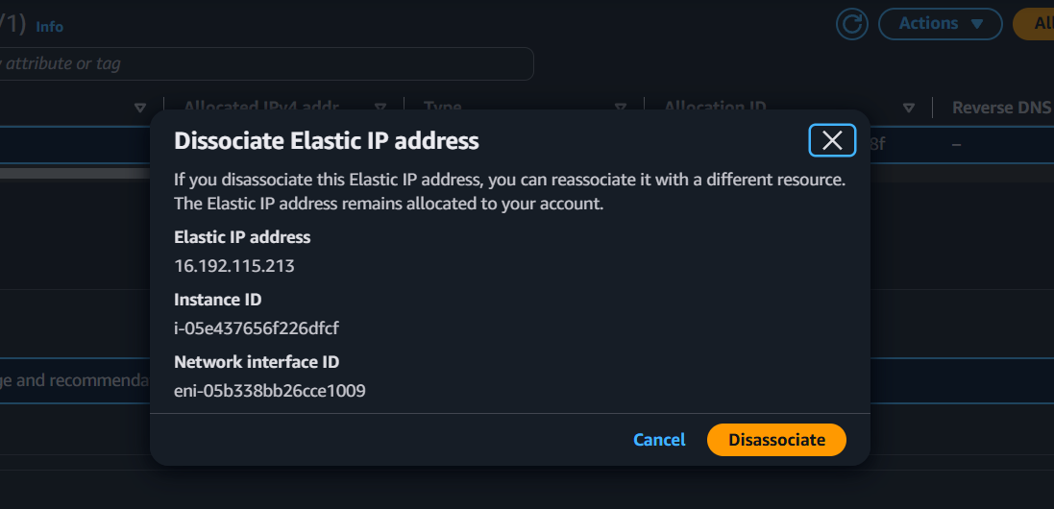

Releasing the Elastic IP Address
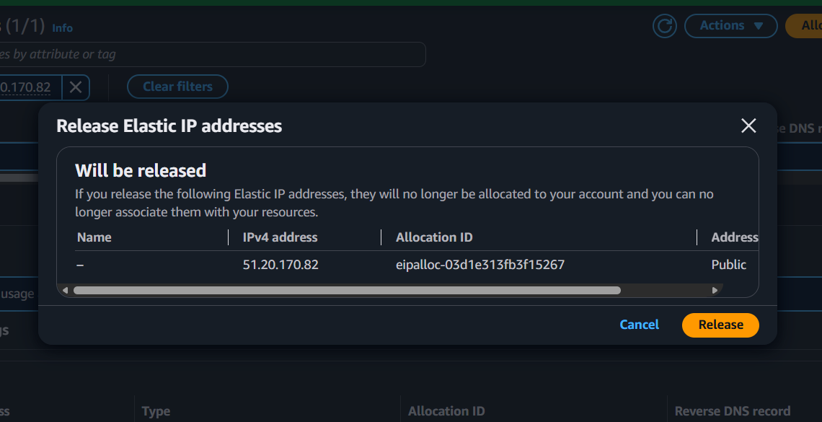

Day 6 AWS

Load Balancing Concepts & Practical Implementation
First we need to Create two instances named as CLB-1 and CLB-2 then we should create the load balancer as shown below:
Click on the create button to create a new classical load balencer
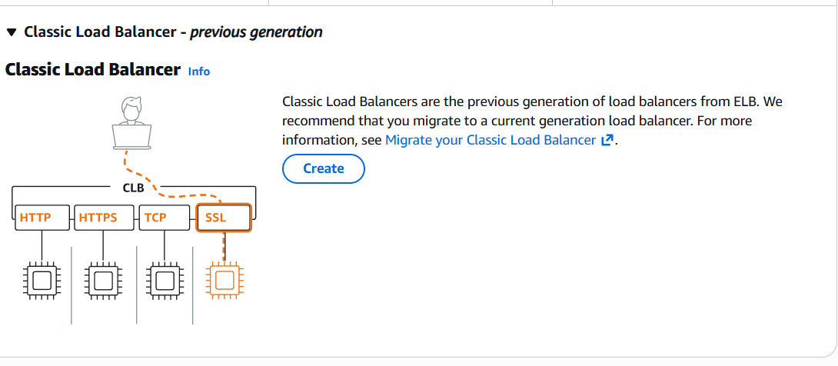

After that it will ask some basic information like name of the CLB you can name anything but it should make some meaning to the CLB and the schema should be in internal-facing if we put the schema as internal then there is no interaction for the public
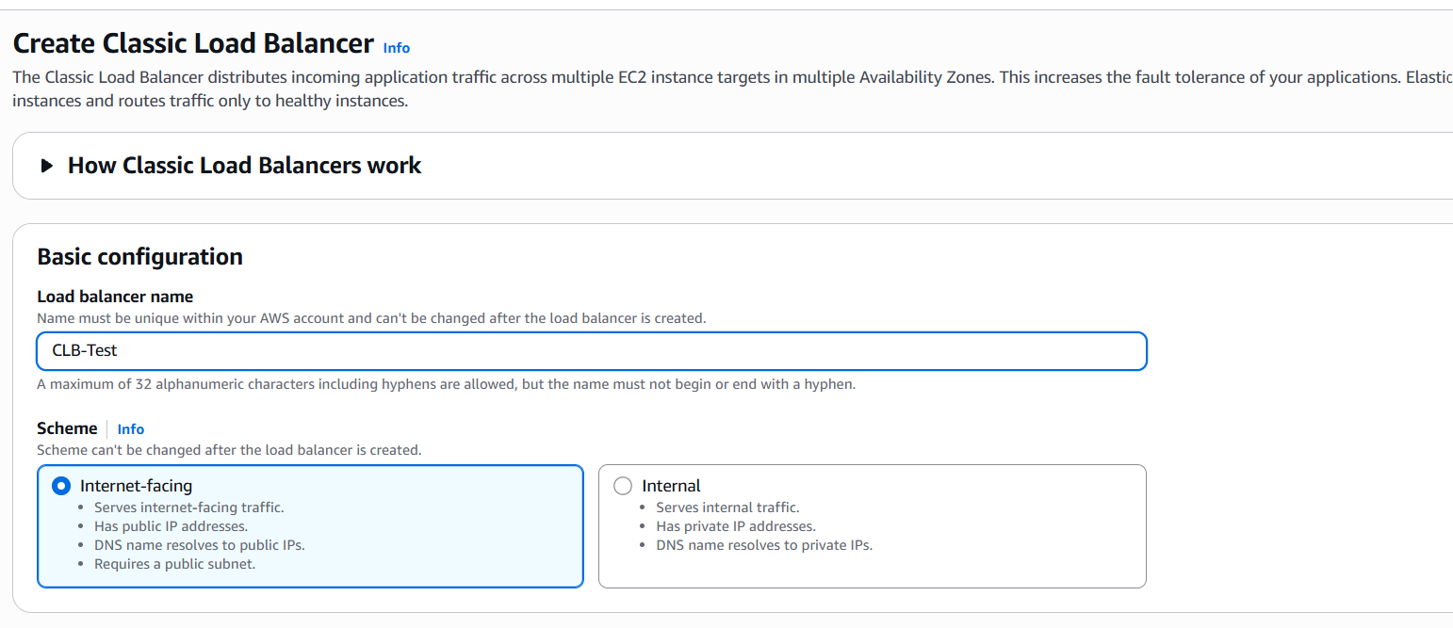

Next we have to select the network availability zone ,here we have to select atleast two availability zones
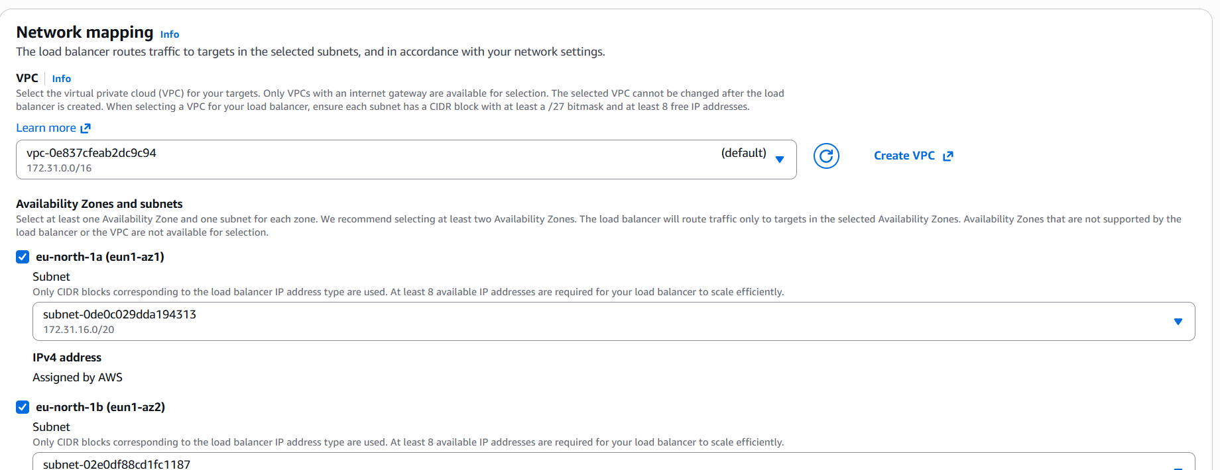

Add the security group for the CLB which is created during the creation of the instances like we have given the Security name as CLB-1 as shown bwlow:
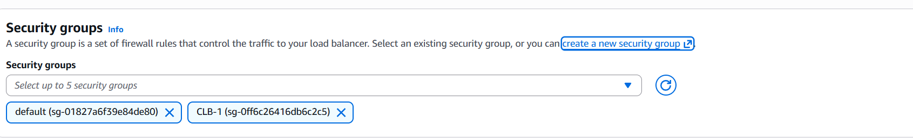

Next section is about Listeners and routing which means A listener is a process that checks for connection requests using the protocol and port you configure. The settings you define for a listener determine how the load balancer routes requests to its registered targets.

And the next section is about the health check , here we can ensure how much of the traffic do our load balancer can handle
There are some setting in this section like
Response timeout : Time to wait for EC2 instances to respond to health checks.
Unhealthy threshold : Number of consecutive health check failures before declaring an EC2 instance unhealthy.
Interval : Amount of time between health checks sent to EC2 instances.
Healthy threshold : Number of consecutive health check successes before declaring an EC2 instance healthy.

After adjusting these setting we need to add the instances which we have created in the beginning :

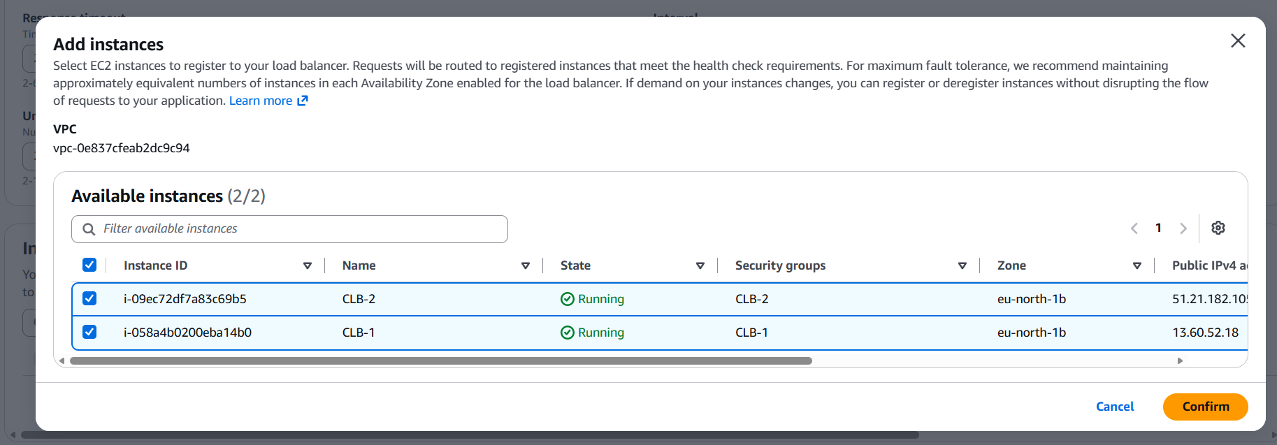

After that we need to click on the crate load balancer to create the CLB
:
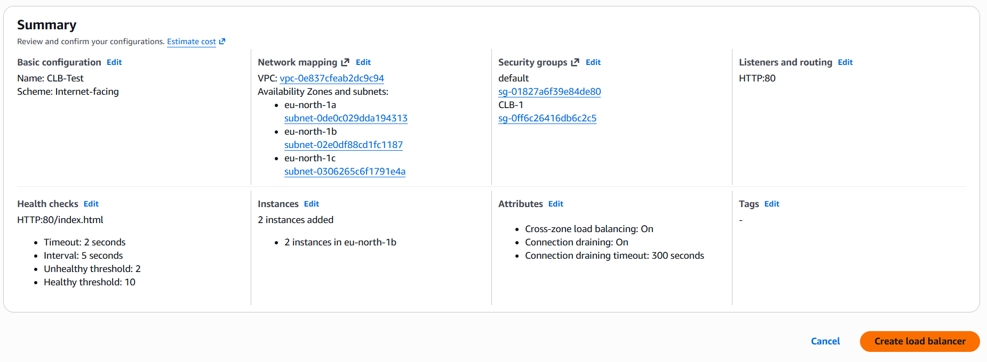

Now go to the load Balancer there we can see the Load Balancer as CLB-Test :
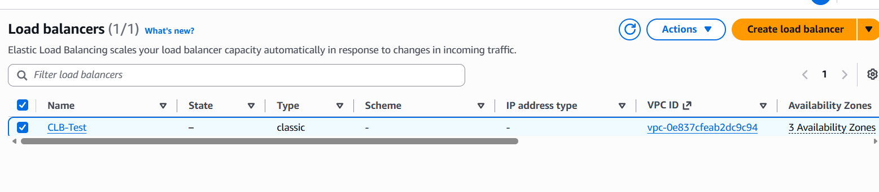
After this we come to Deleting the instances first go to the load balancer than go to Action first delete the Load Balancer :
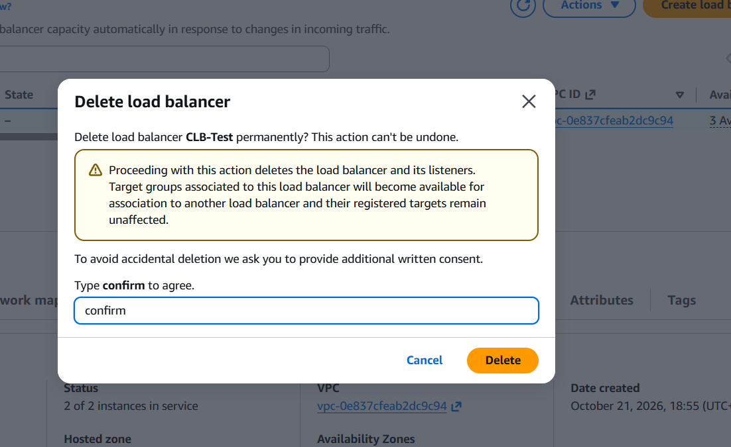
Then go to the instances select the instances and go to instance state and then do the delition :
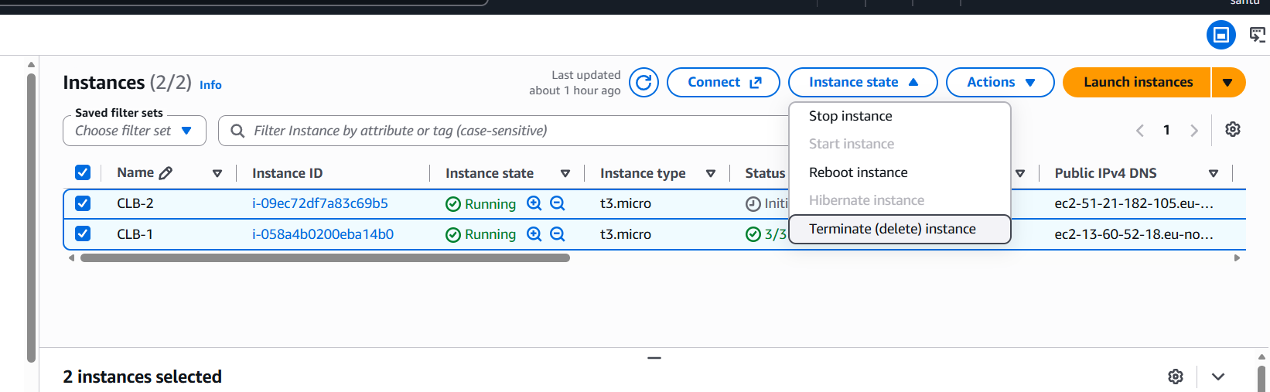

Day 7 AWS

Storage
There are three types of Storages in AWS
- EBS (Elastic Block Storage)
- EFS(Elastic File System)
- S3(Simple Storage Service)
1.EBS : one EC2 Machine can have multiple volume and also additional volume which is know as EBS
Root volume
EBS volume (Pendrive , SSD, Hdd,etc)
Create a instance named as EBS-1 Also give the key-pair value as EBS-1 and under the network setting select the Availability zone as eu-north-1a as shown below:
And in configure Storage add another configure storage of 15gb as shown below and launch the instance :
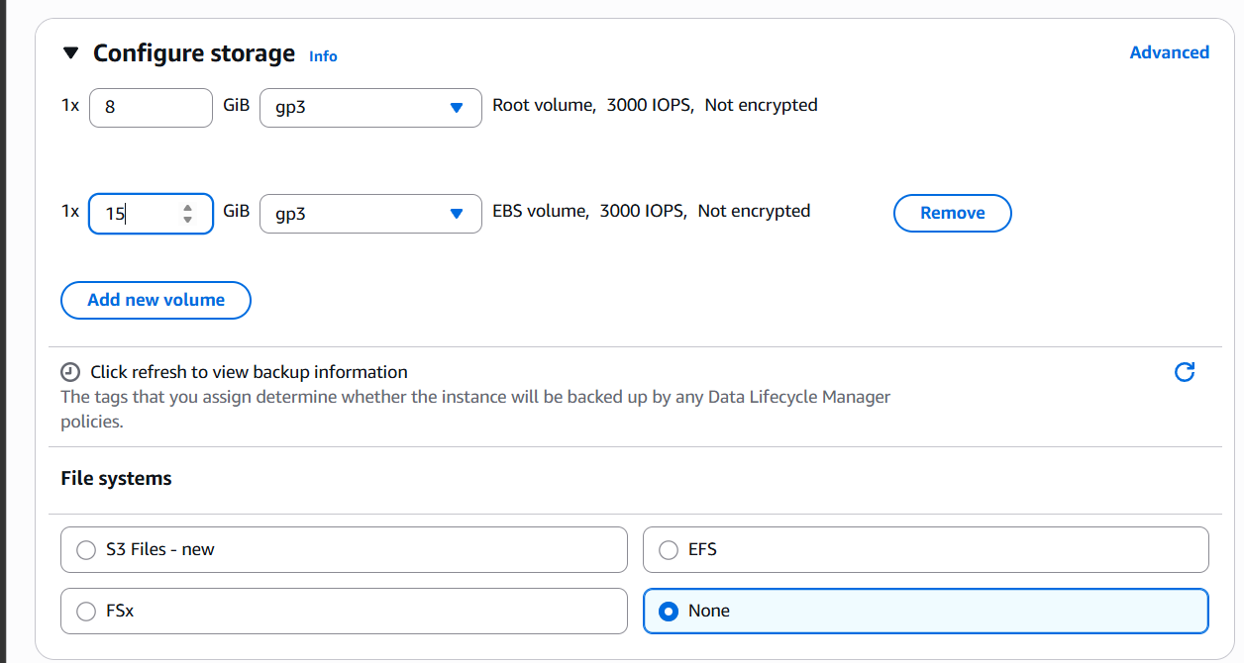
After this create another instance which has the same availability zone as the peviese one and there is no addition of attaching the additional volume or storage for this instance
Next we need to connect to the instance 1 for that click on connect button and there we can see the section called how to connect :
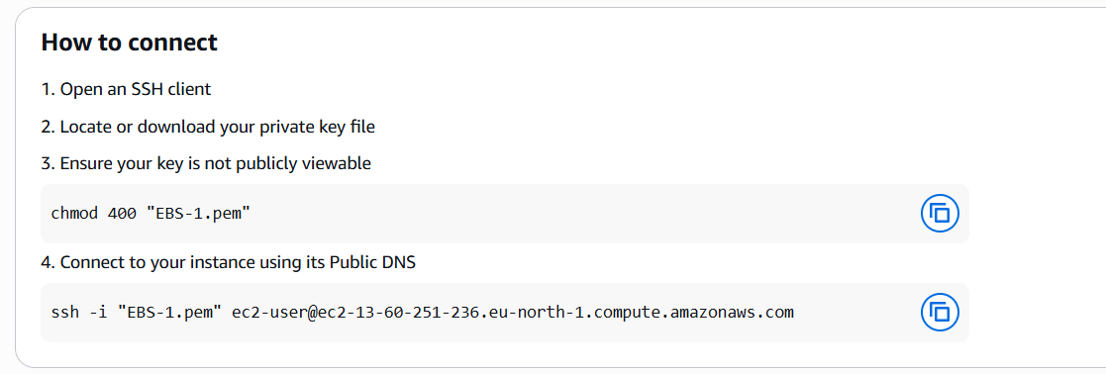
Now open the command prompt and go to the file location where the key value is located and paste the command which is staring with “ssh –i” after that you can see which means we are sucessfully connected to our first machine :
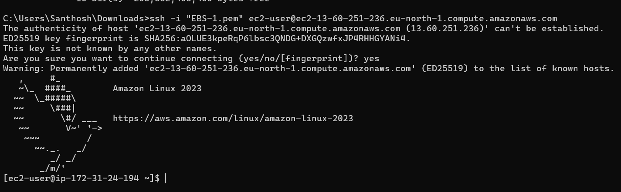
After connecting to the machine we need to pass the command sudo ndf update –y to updatet the current machine and the pass the commad called df –hT which is used to free the disk there df Stands for Disk Free After passing this command we can see the root volume i.e 8gb but we can’t see the 25gb volume :
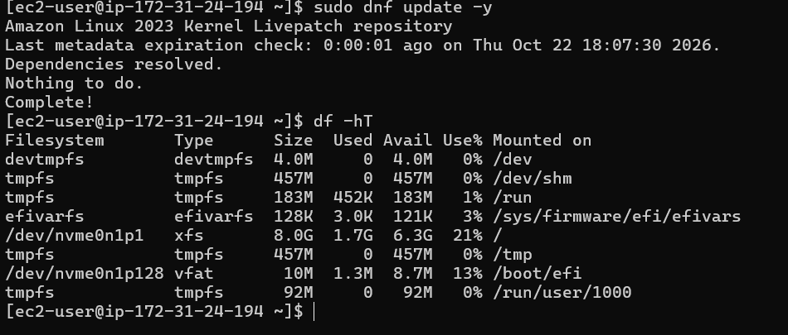

To get the information about the file system we use the sudo file –s /dev/xvdb( the /dev/xvdb may be replaced by the file mane) in my system the file name is /dev/nvme0n1p128 so I will send the command as sudo file –s /dev/nvme0n1p128
Now we need to create a file system for that the command is:
sudo mkfs –t ext4 /dev/nvme1n1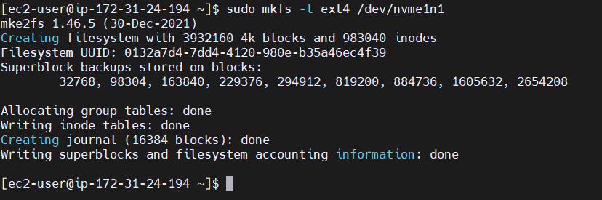
and the 15gb storage will not be visible because we did not mounted to any folder so that’s way we can’t see the 15gb storage so do that first we need to create a directory name as test for mounting the storage use the command : sudo mount /dev/nvme1n1 test here we have successfully mounted the storage to the file now if we pass the command df -hT we see:
Now move to the test directory and just create some files or directories if we pass the command as mkdir dir{1..100} there will be creation of 100 directories

So before unmounting the storage we need to get out of the current directory so we should pass the command as cd ... and then for unmounting the storage we need to pass the command sudo umount test :
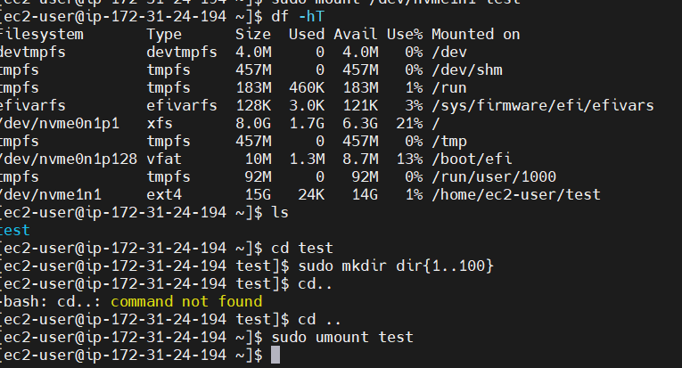
After this we need to detach the storage from the console so go to the volumes and click on the volume which as 15gb storage click on action and detach the volume :
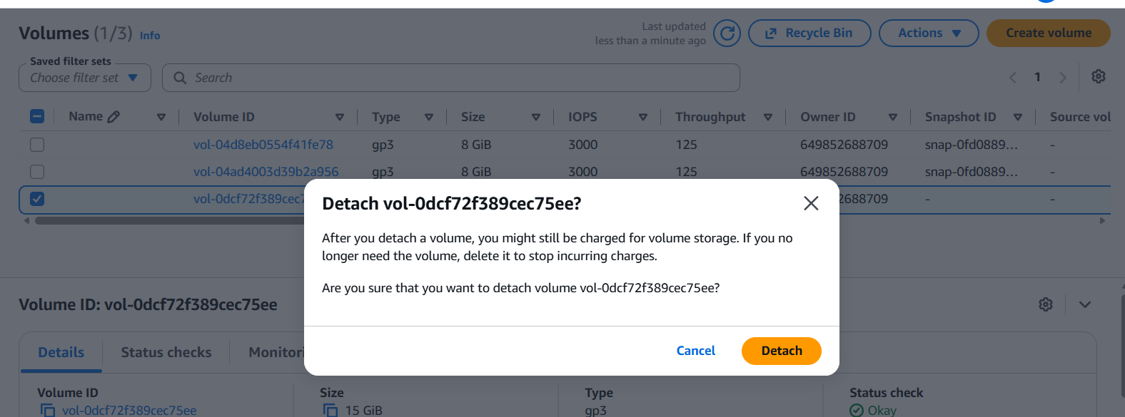
Now we need to Attach this storage or volume to the 2nd machine inside the console select the volume and click on attach volume and then enter the name of instance and enter the device name and click on attach volume and you should get the message popping up as successfully attached volume :
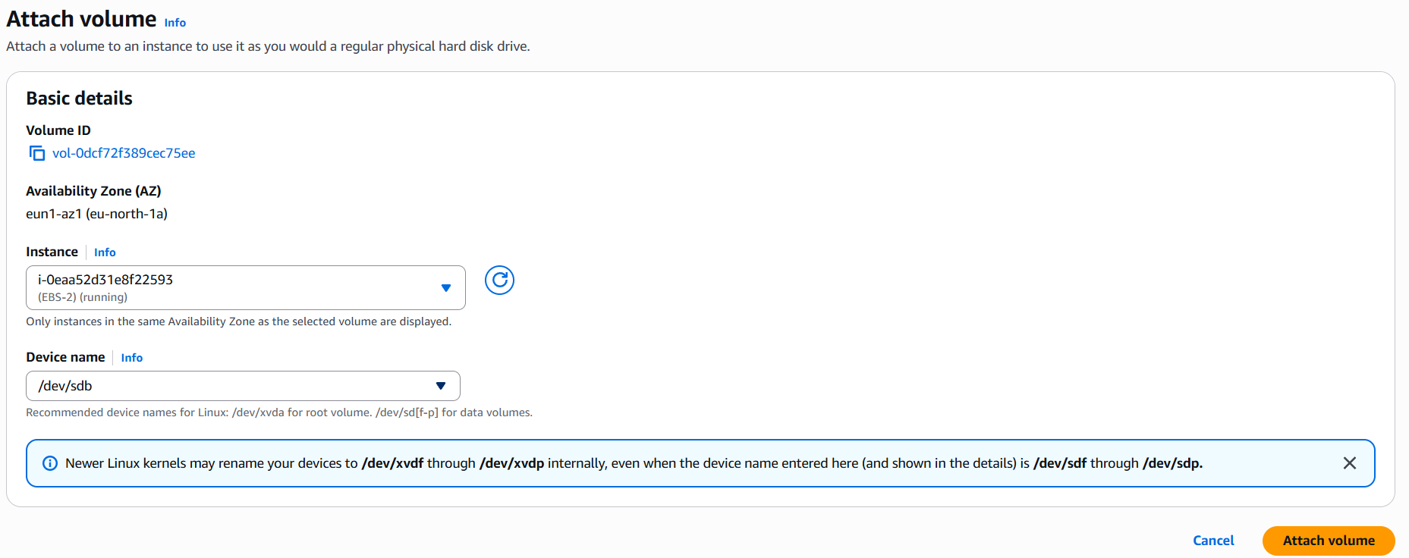
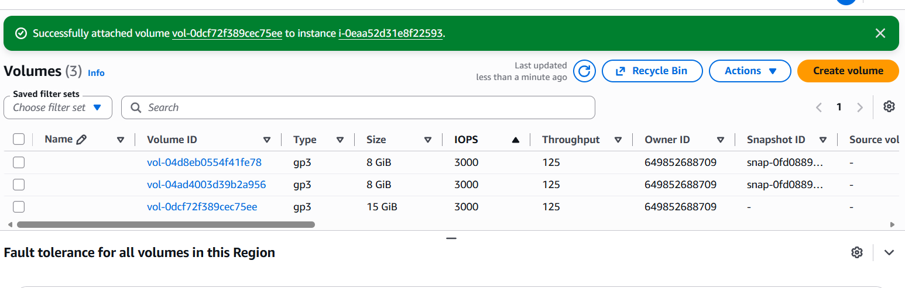
After that open the instance in the command prompt and pass the command as lsblk you can see that the 15gb is also attached to the machine now create the directory in the machine like mkdir test1 and mount the disk to the directory sudo mount /dev/nvme1n1 test1 and switch to that directory and then if you type ls command we can see that the files or directories which we have created in that instance 1 are been copied into the instance 2 :
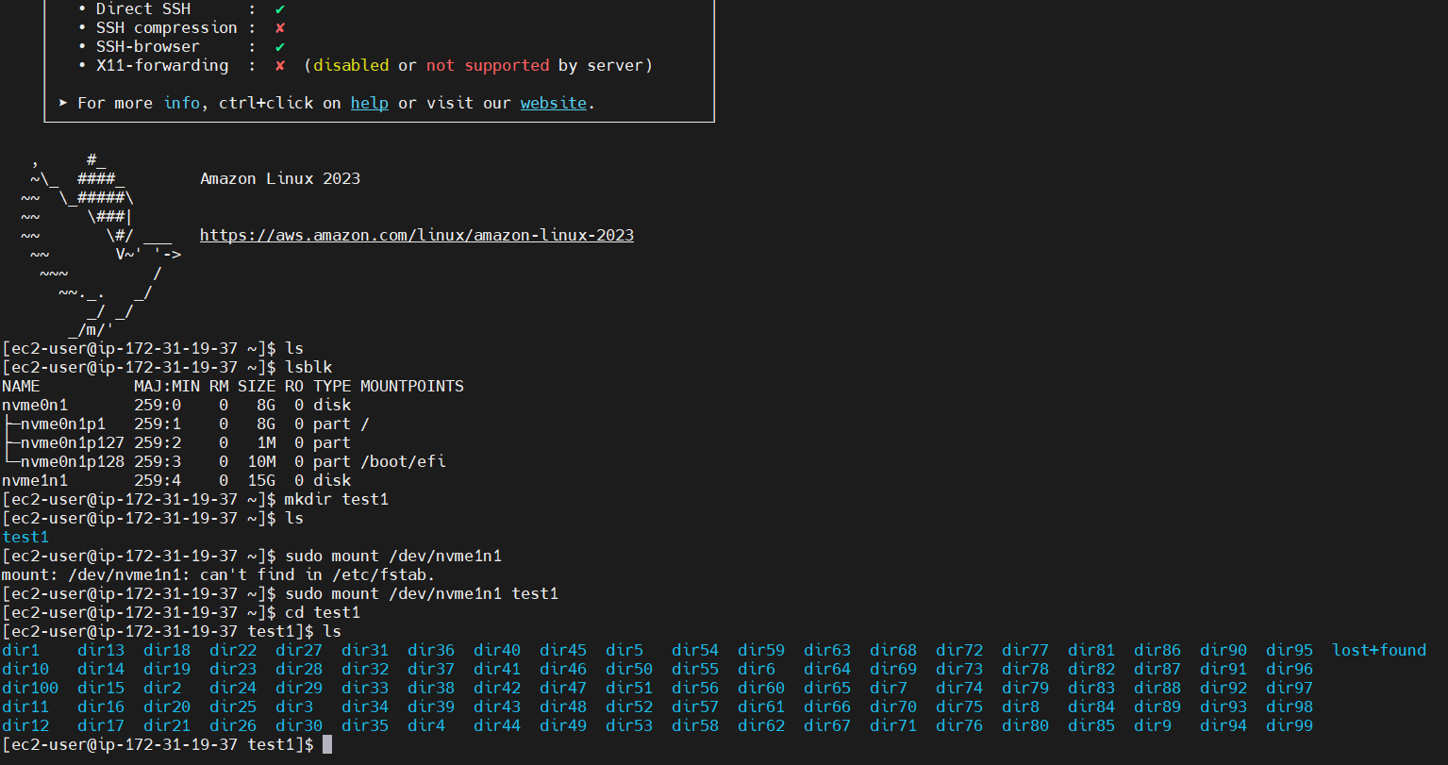

Day 8
S3 (Simple storage Service)
S3 is a secure, Durable and highly scalable object storage .it is easy to use
with a simple web service interface to store and retrive any amount of data from anywhere on the web
it can be used to store and protect any kind of data for example ;
- data lakes
- websites
- mobile appl
- backup and restore
- archives
- enterprice applications
- IOT devices
- big data analystics etc....
Features of S3
----------------
1. it is a global service
2. low latency and high throughput performance
3. it is a safe place to store your files
4. it is a object based storage
5. Durability
6. a single amazon s3 object can store max of 5 terrabytes. the total volume that an s3 bucket can store is unlimited.if the object size is greater than 5 gigabytes, you should consider multipart upload
7. S3 bucket names must be unique globally
8. lifecycle management
9. S3 bucket names must be unique globally
10. lifecycle management
11. versioning
12. encrytion
13. ACL & Policies
14. Intergrations
Amazon s3 Allows people to store objects (files)
in the buckets (directories)
Buckets must have a globally unique names
Buckets are defined at the region level
Naming Convention
No Uppercase
No Underscore
3 - 63 charcters long
Not an Ip
must start with lowercase or number
After this Login to the console and go to the S3 in that S3 yu can see the option or a button called create bucket juct click on it and you can see :
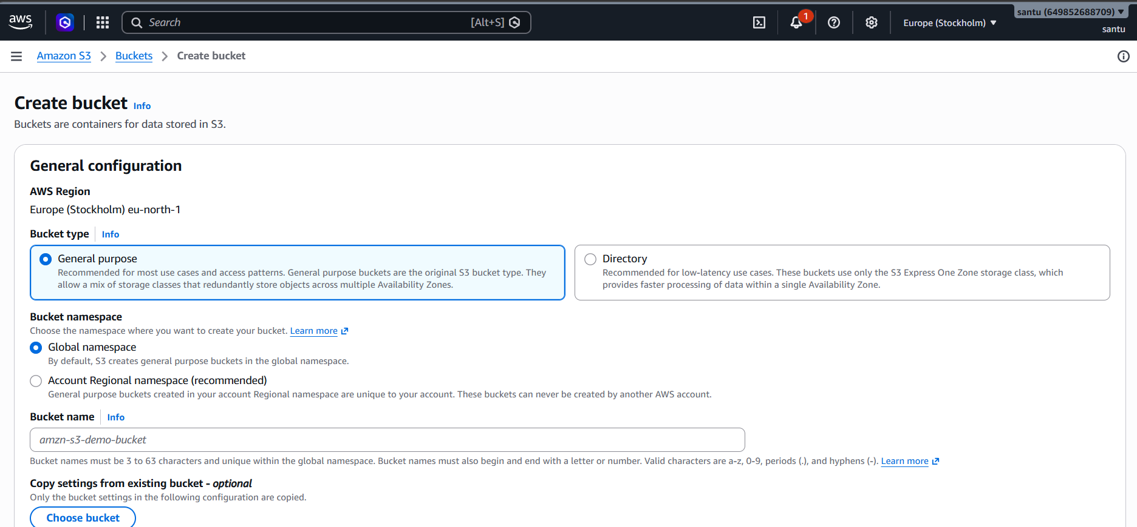
Enter the name of bucket and there will be another section called Object Ownership select the ACL disabled (ACL stands for Access Control List ) and click on the Block all public access
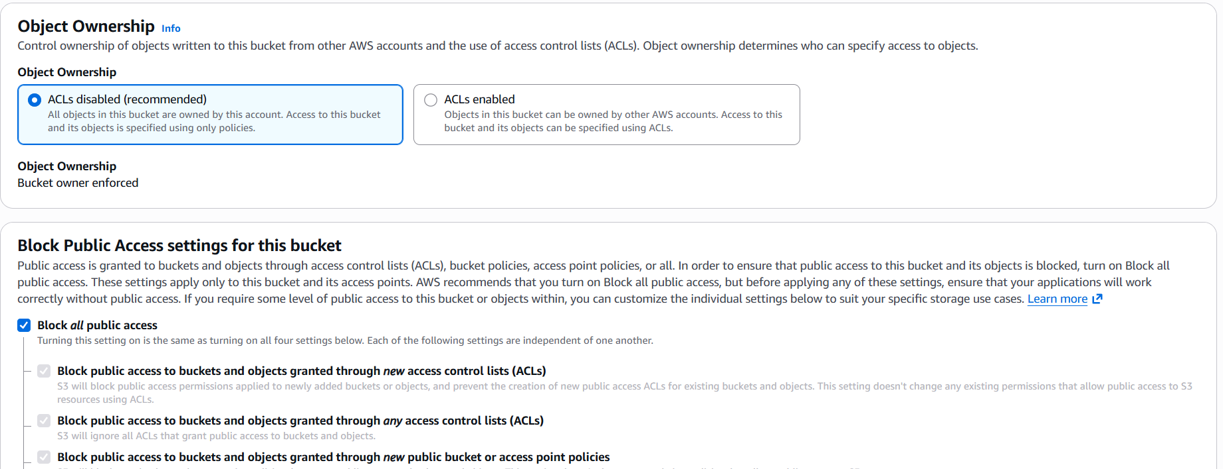
And click on the create bucket option and now the bucket is created now we can see many options on the screen click on the uplode button and upload the image or anything on that storage or a bucket and when we try to open that file we can’t see any image on the server :
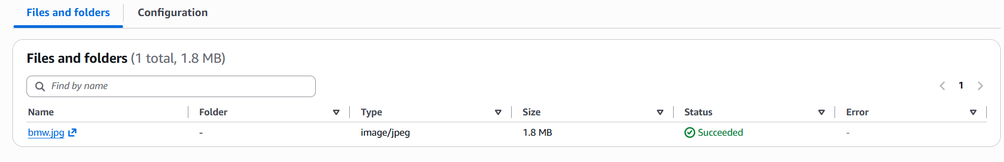
When we open the Object URL we can’t see the image :
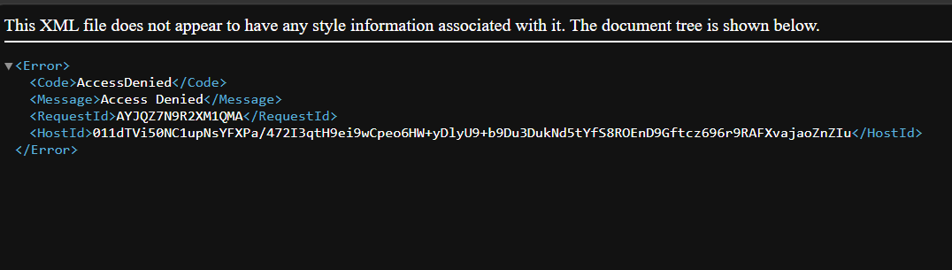
It is because we have disabled the public access so to enable that we need to go to the permission and grant all the permissions to the public or uncheck the Block public access button :
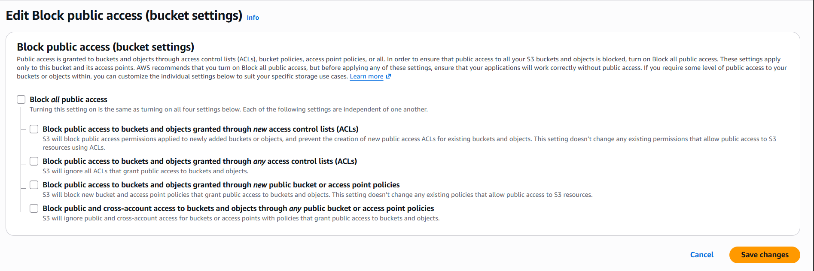
Eventhough giving the public access we still can’t see the image on our server or bucket because we have only given the public access to the bucket level but we never given the access to the object level so we can’t see the image so for giving the permission or public access to the object level go to the object and inside the permission section we can see the edit option click on that button :
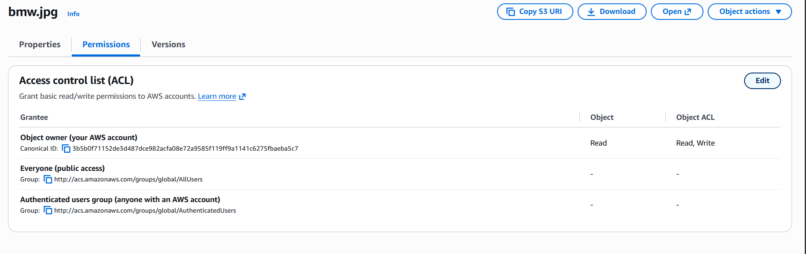
Here we can see the options like Object Owner , Public Access ,beside that public access we can see the two checkbox’s just check these boxes and then give the Authentication for the public access then click on save changes After this when we open the Object URL we cann see the image or any content of that particular bucket :
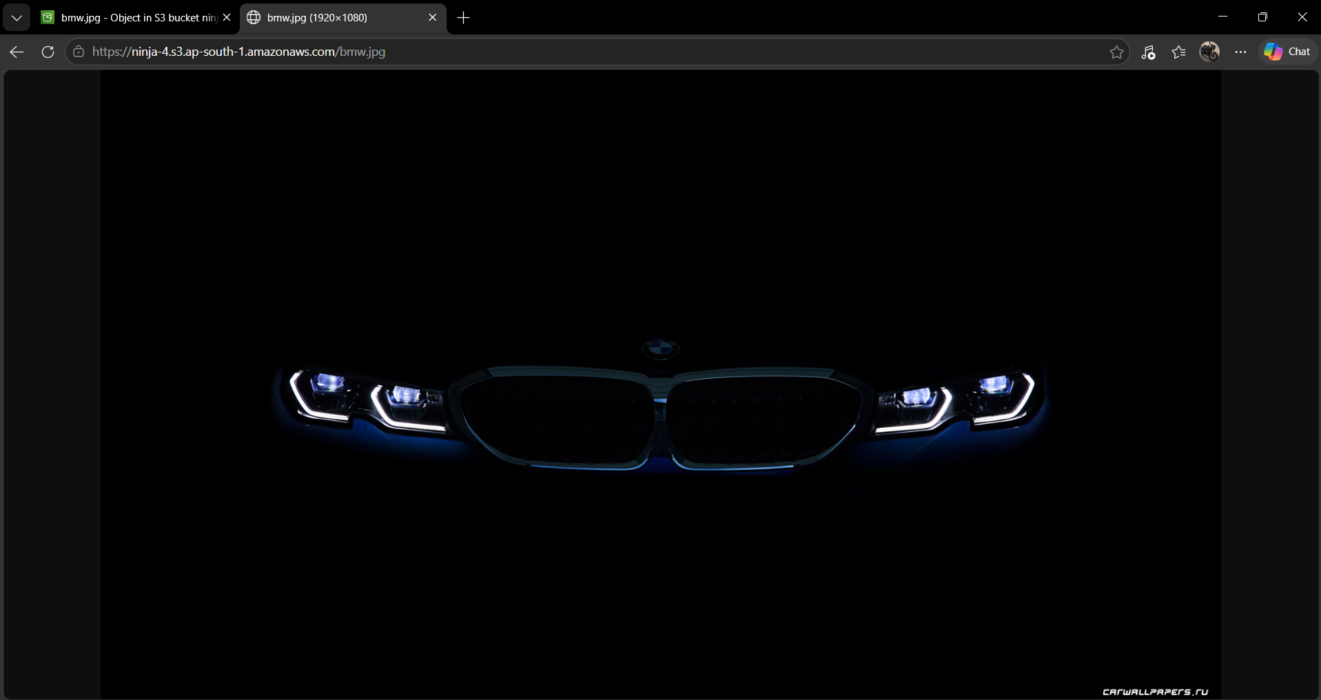
After this we need to delete the bucket just to reduce the amount ir charges which can be given by the AWS :
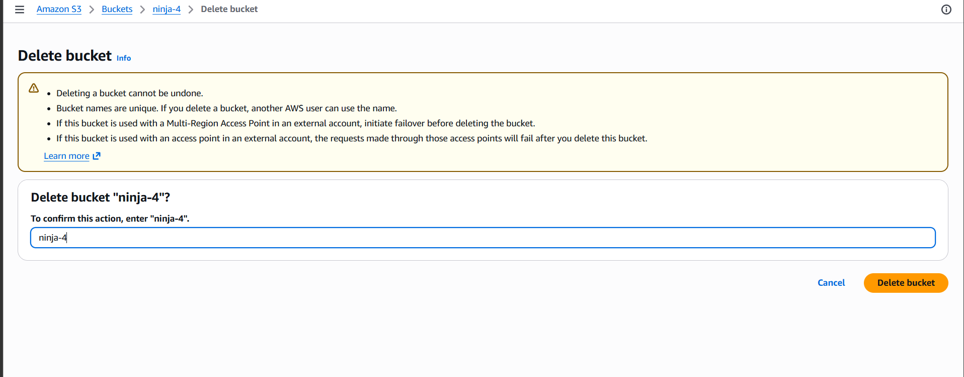

Day 9 of AWS
AutoScaling
Amazon EC2 Autoscaling helps you to maintain application availability and allow you to automatically add or remove EC2 machines according to conditions you define
There are two types in Autoscaling :
1.Vertical
2.Horizontal
First we should create the instance let name it as autoScaling then we can change instance type by selecting the instance time as tc3 micro to tc3 large by doing this we get more storage and CPU Even we can modifiy the volume of the nistence by clicking on the action buttion there we can see the modify volume button just click on it and upgrade the volume let’s say to 15gb but by this method we can just increase the size of harddisk but we can’t decrease it’s volume this method is known as vertical Autoscaling
For creating the Auto Scalimg first we need to create a template for creating the template go to template option and click on launch template it will ask d=some details fill the details like name of the template and description and select the operation system under the Quick Start and create the key-pair now under the network setting we need to enable the ssh and http port like:
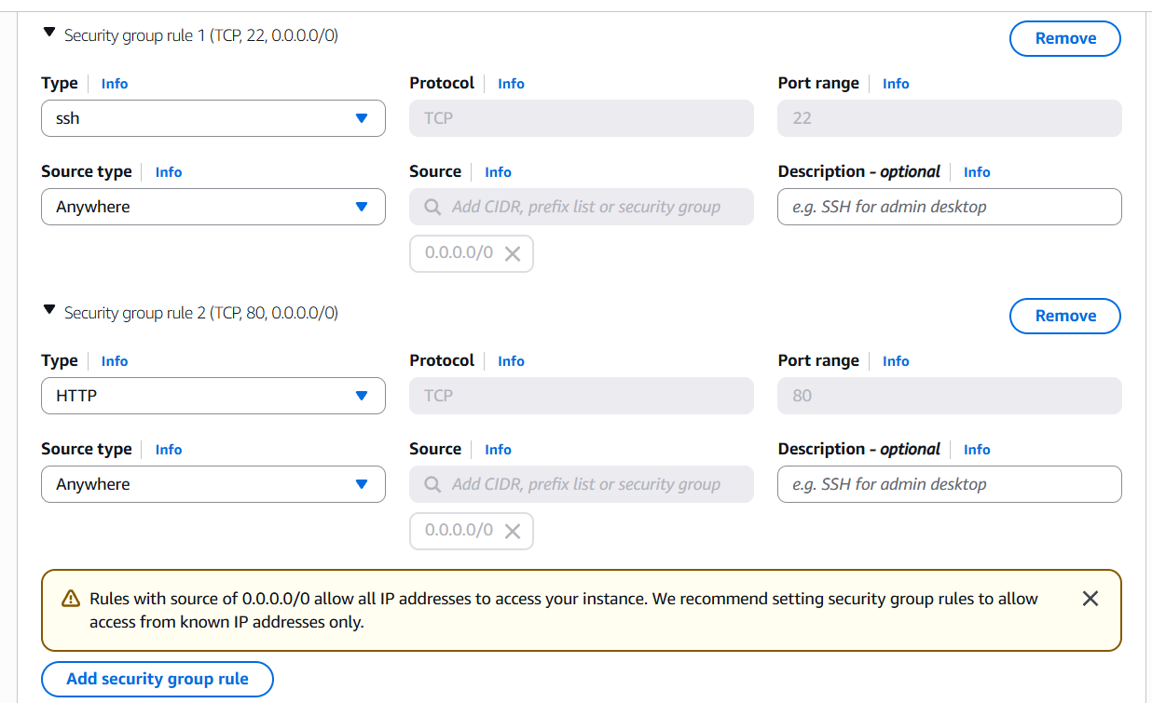

Ater this click on the launch template to launch the template

Now we need to create the SNS (Simple notification Service) for this go to searchbar and search as sns then we can see the sns as:
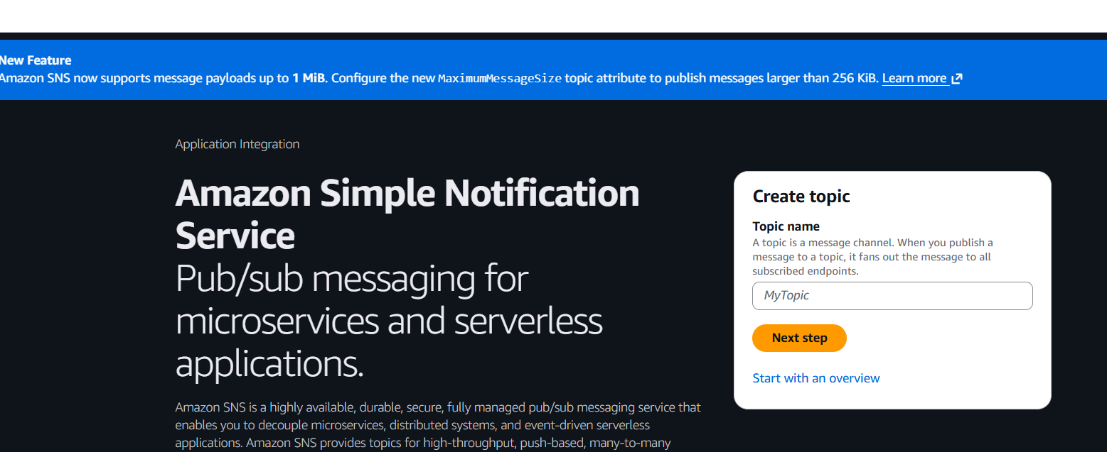
Just enter the topic name and click on next step Ater that just enter the description for that sns and click on create topic now go to subcriptions and click on create subscription :
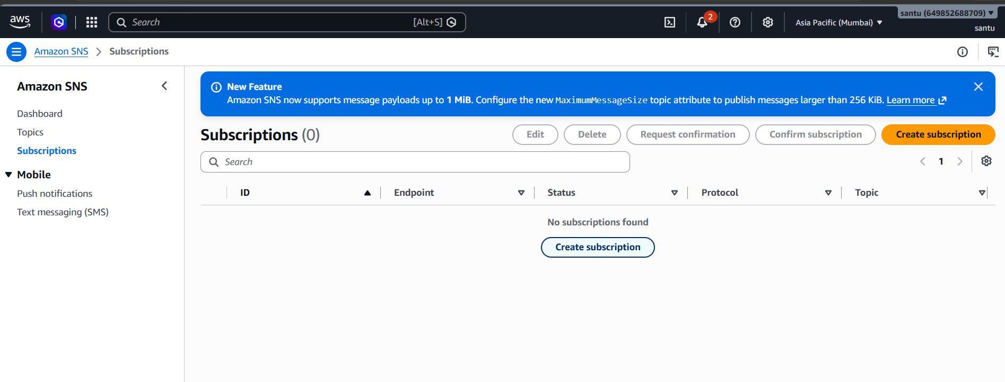
Enter the Topic ARN chose the protocol whichever you want then enter the end point and click on create subscription After this we will get an Email to conform the subscription on the respected Email :
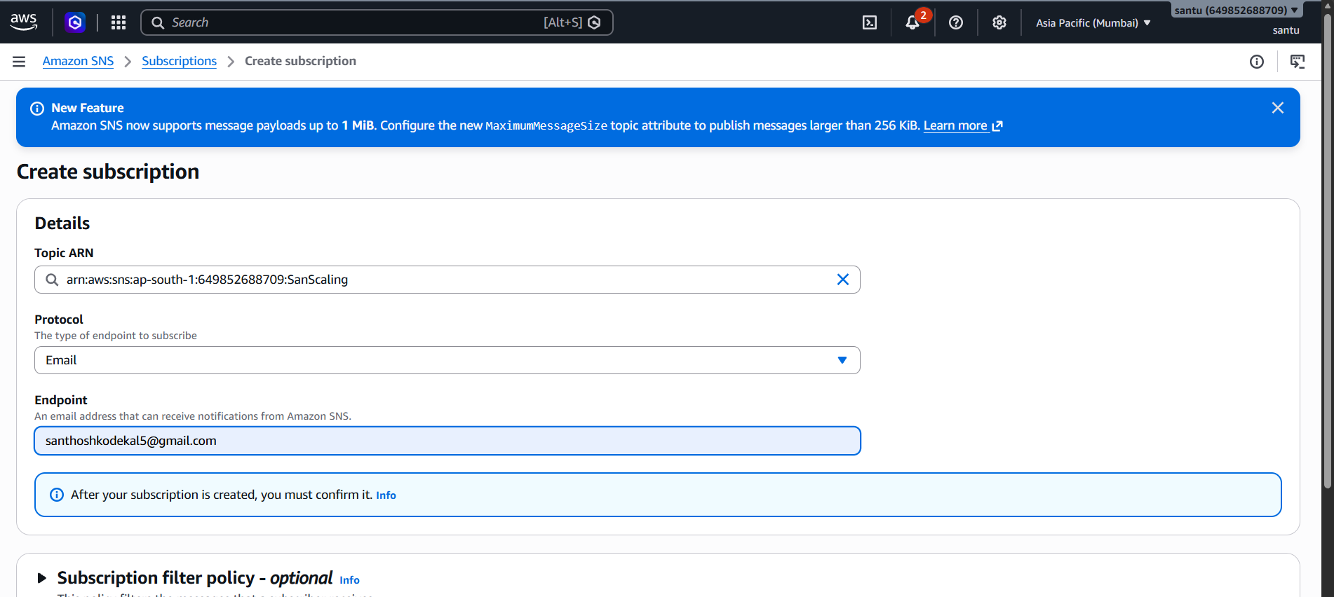
After this go to the Auto Scaling Groups and click on create new Scaling group now we should enter the name of the scaling group and select the template which we have created and click on the next button :
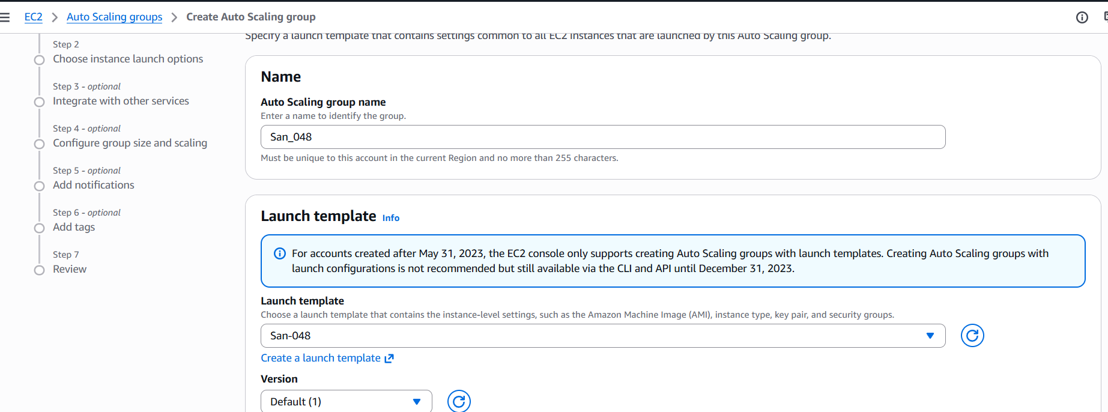
Next step is choosing the instance launch options insid ethat we have section for selecting the availability zone we should select all the availability zones and click on next button :
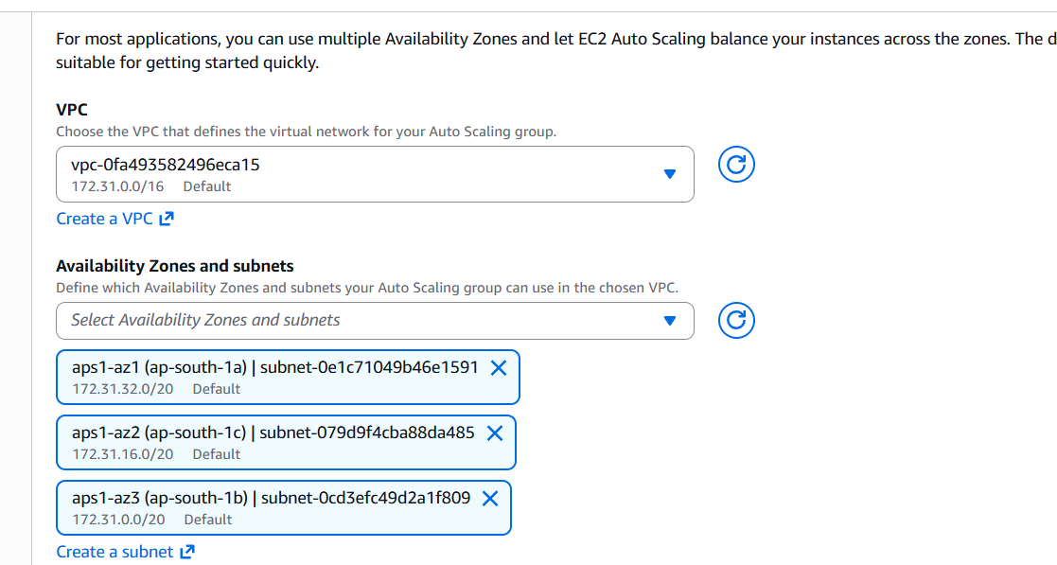
After that move on to the Attaching the Load balance there we can see three options add no load balancer Add the existing load balancer and create a new load balancer just select any one of tehn proced to the next step :
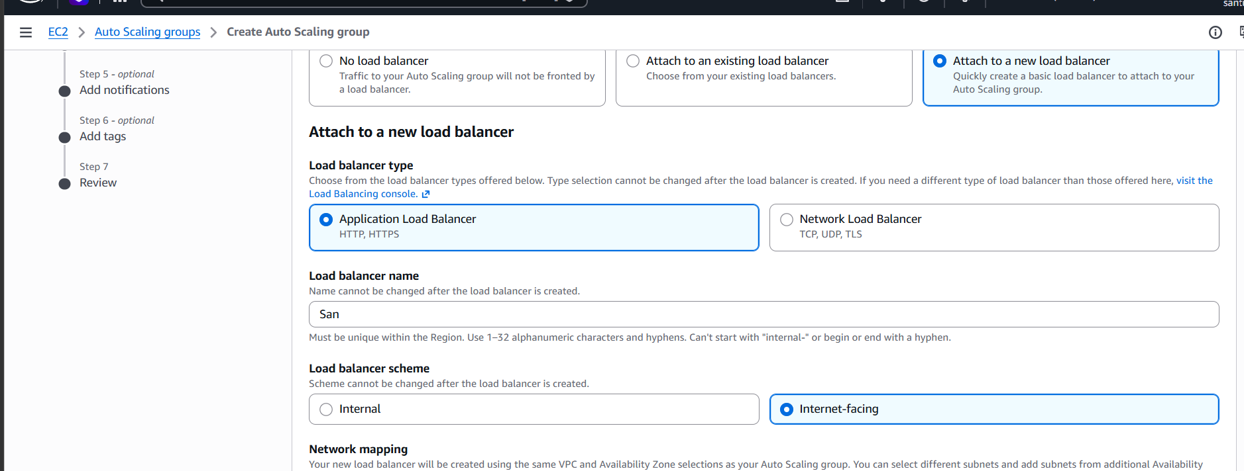
The next step is Configure group size and scaling there we can see an option called desired capacity jist adjest the seting with your needs and go to the next step :
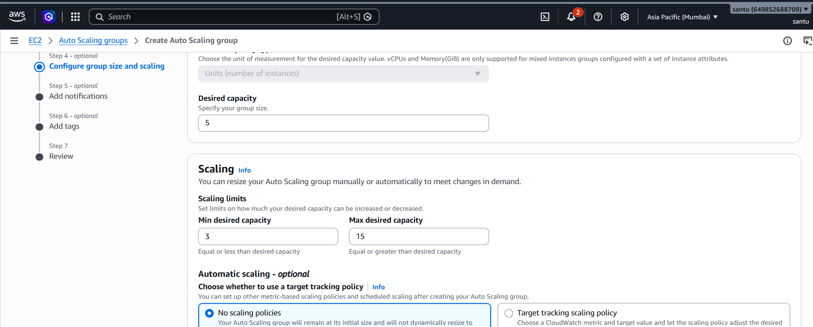
Next step is Add Notification click on the Add notifications and add the SNS Topic which we have created:
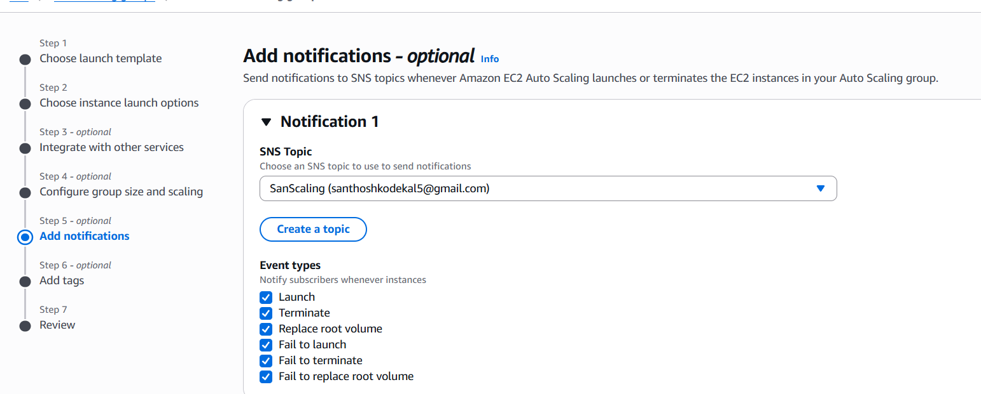
Now click on create Auto scaling group now we have successfully created the auto scaling After this when we click on launch template and go to the instances we can see that at default 3 instances are running :
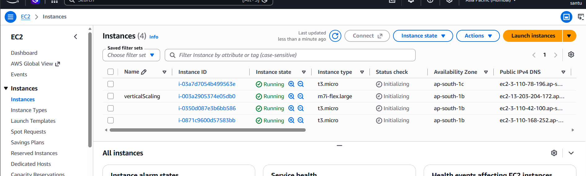

Day 10
VPC-Virtual Private Cloud:
In this day we have understood the architecture for building the VPC Private cloud :

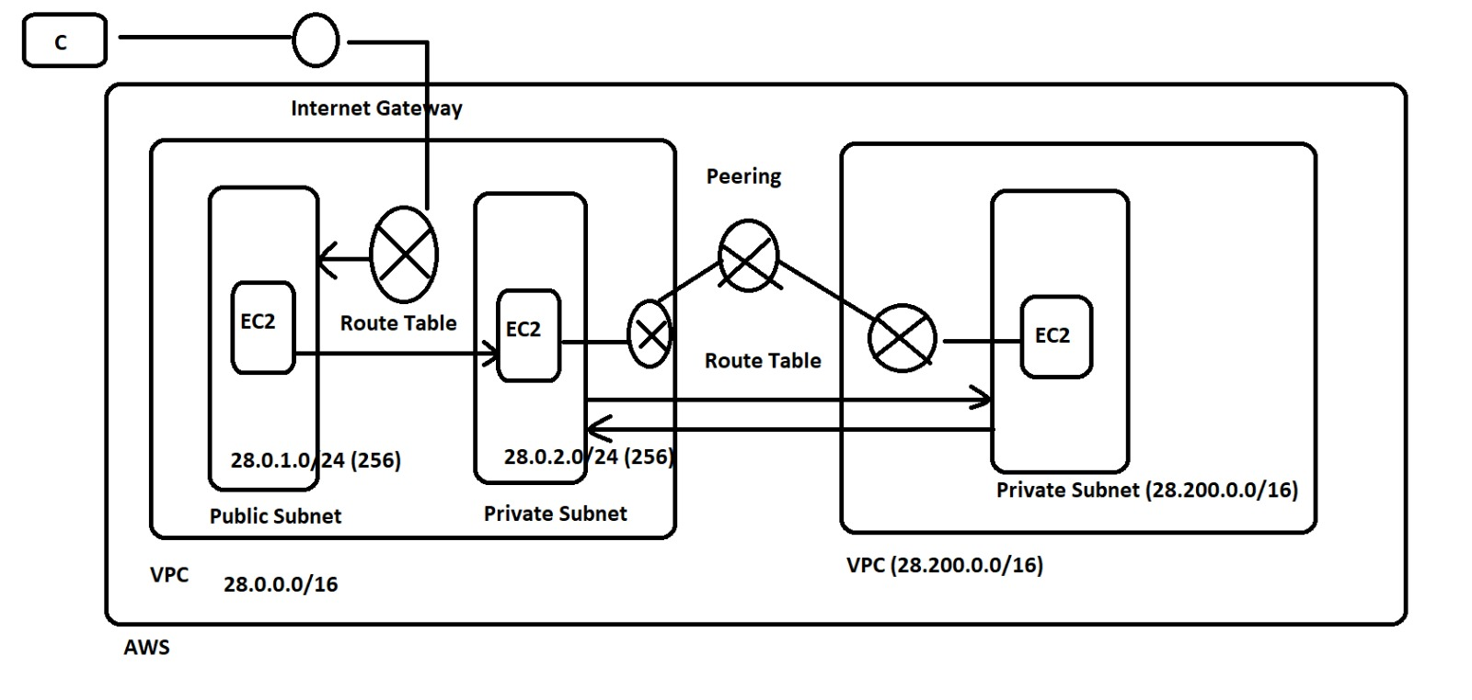

PROJECT:
For creating the VPC fir we should have a AWS Account and after that we should create the VPC servers for creating the VPC open the AWS console and search for VPC there we can see a option called create vpc click on that option we will get an interface :
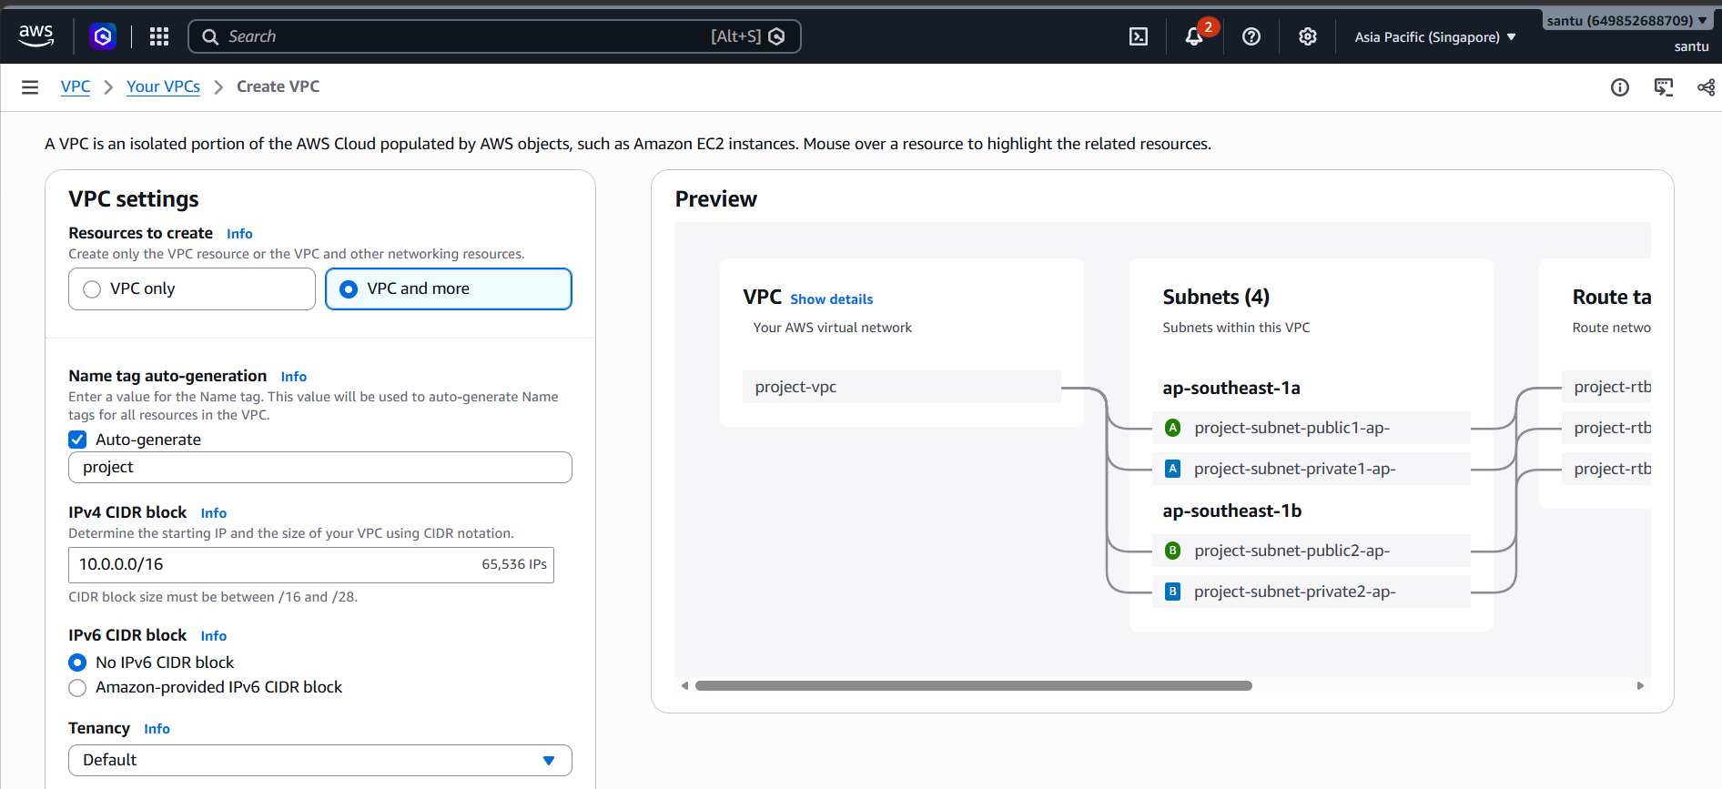
In that we will have two options like only vpc and vpc and more we should select the only vpc and we should enter the bacic Informations like name of vpc, IP Address for the VPC and if we click on your VPC we should see our VPC as available :
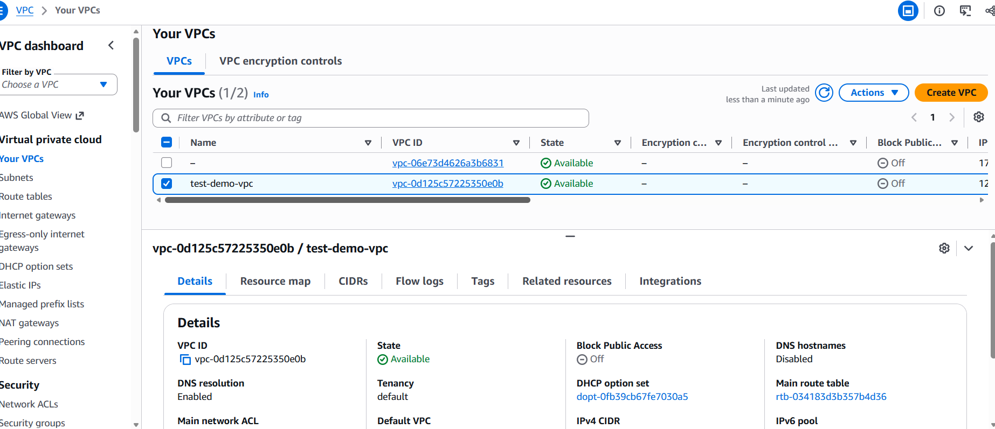
Next thing is we need to create the gateway so that we can associate that with our public and private subnet to create this we need to go to internet gateway option which will be present on the left hand side of the console click on the create internet gateway here we need to enter the name for the internet gateway and click on the create internet gateway button :
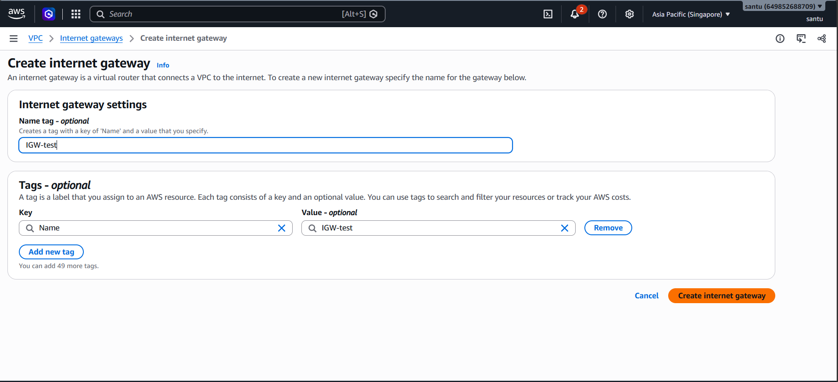

After creating the internet gateway first we need to attach that gateway to our VPC so to attach that gateway to the VPC me need to click on the internet gateway ID and that we can see a slide down window called Actions there we can see an option called attach VPN click on that and attach the VPC :
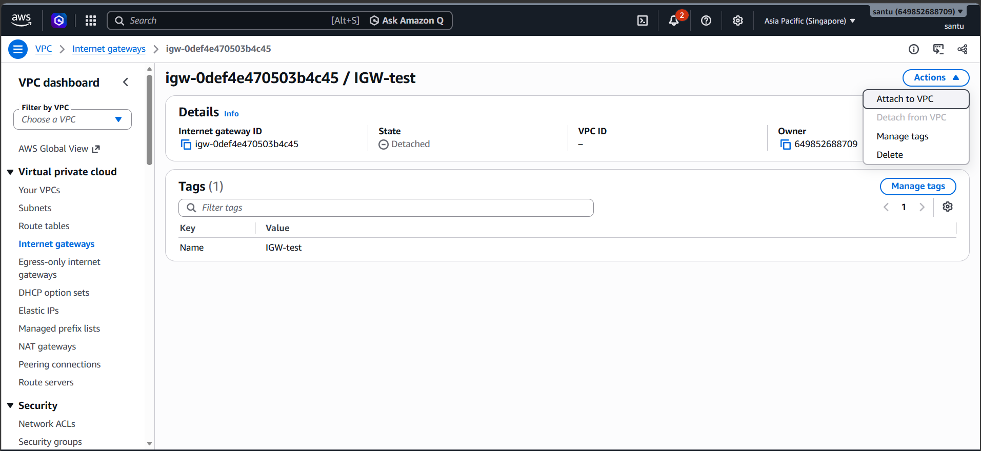

Now we need to create our public and private subnets for creating these subnets go back to the VPC console and below the your VPC we can se an option called subnets click on the subnets click on the create subnet button there we see the fields like VPC here we should select the VPC for which we need to create the subnet and then add some basic informations like name for the subnet selecting the availability zone and specify the IP range enter the public IP range and create the private subnet same as the public but give the different IP range then click on the create subnet button : 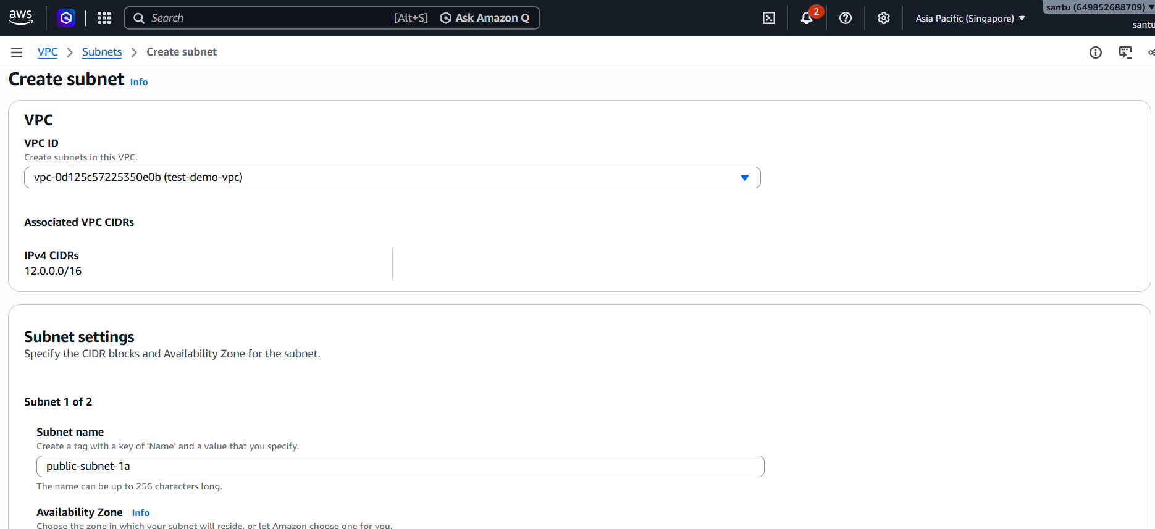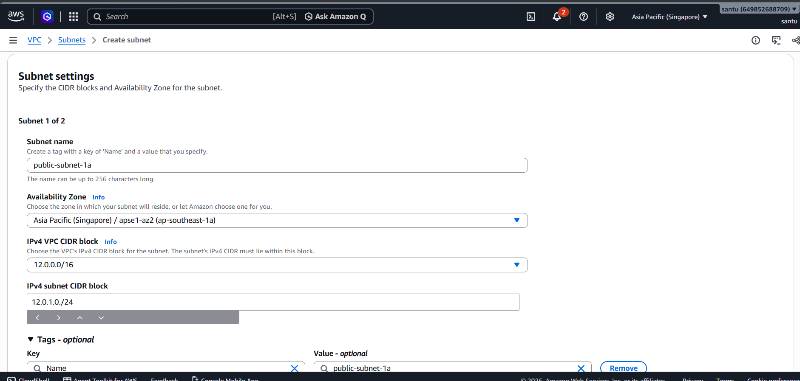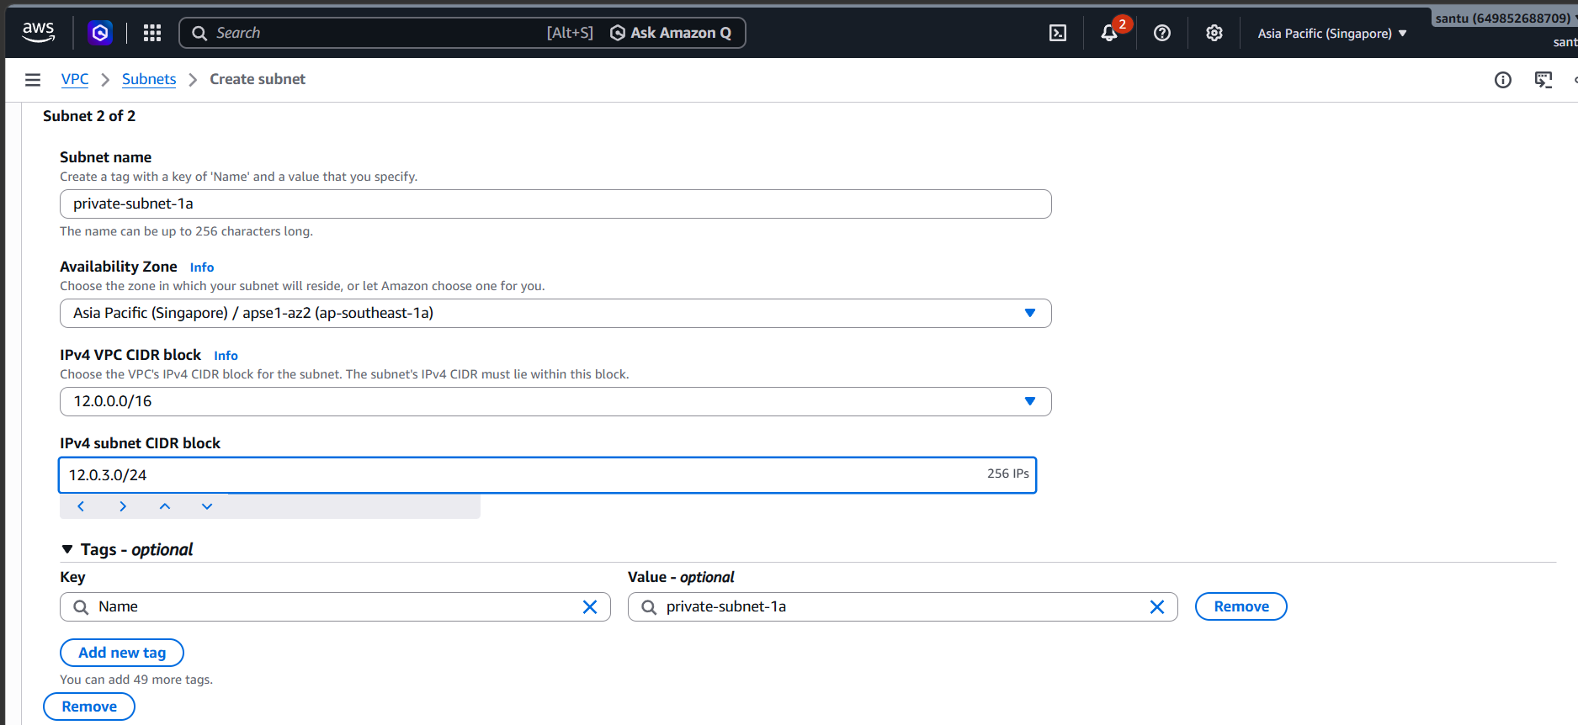
After creating the subnets we need to create the route tables create the routable by navigating to the routetable on the VPC console click on the crate new routetable enter the route table name and select the VPC and click on create routtable button :
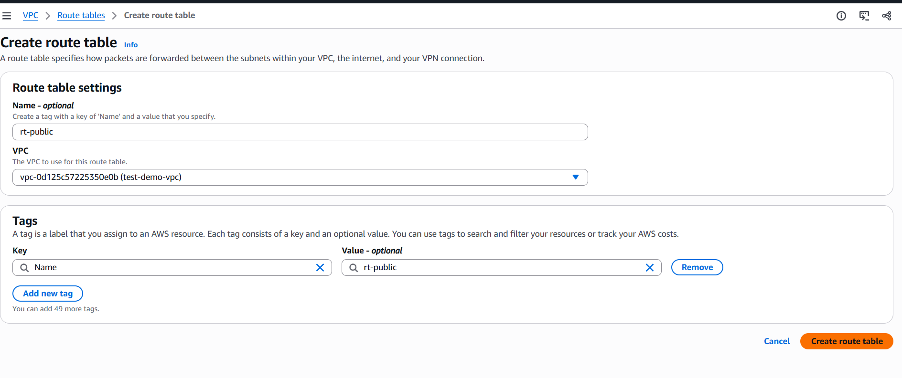
For internet access we need to create a rount so click on the edit option and click on add route and add the route and enter the IP as 0.0.0.0/0 and set the target as internetgateway now click on save changes :
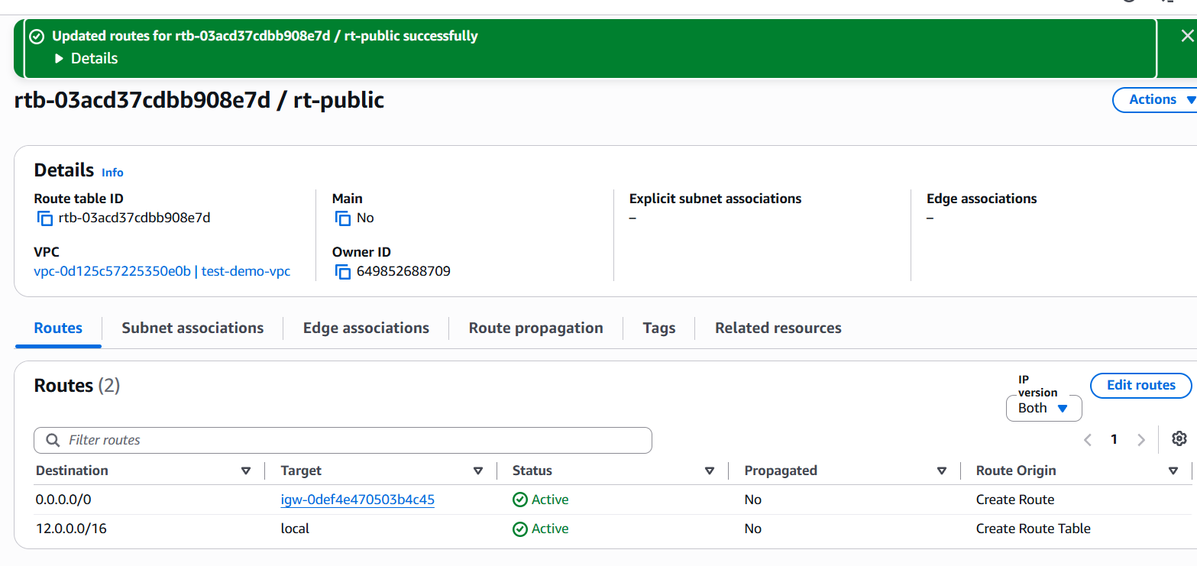

Now we need to associate our route table to our public subnet server go to the route table and click on the subnet association and click on the edit subnet association there we will find the both public and private subnets select the public subet association and save the association :
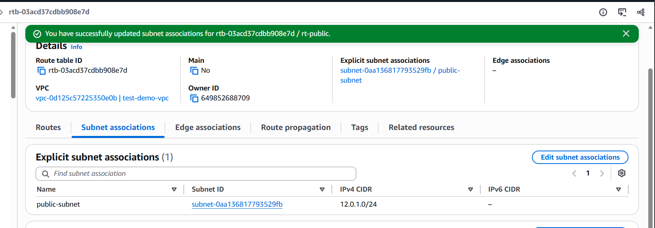
Next we need to create the rout table for our private subnet follow the same instructions as we have done in the creation of previous route table and also create the subnet association click on subnet association click on edit option and choose the private subnet and sane the association :
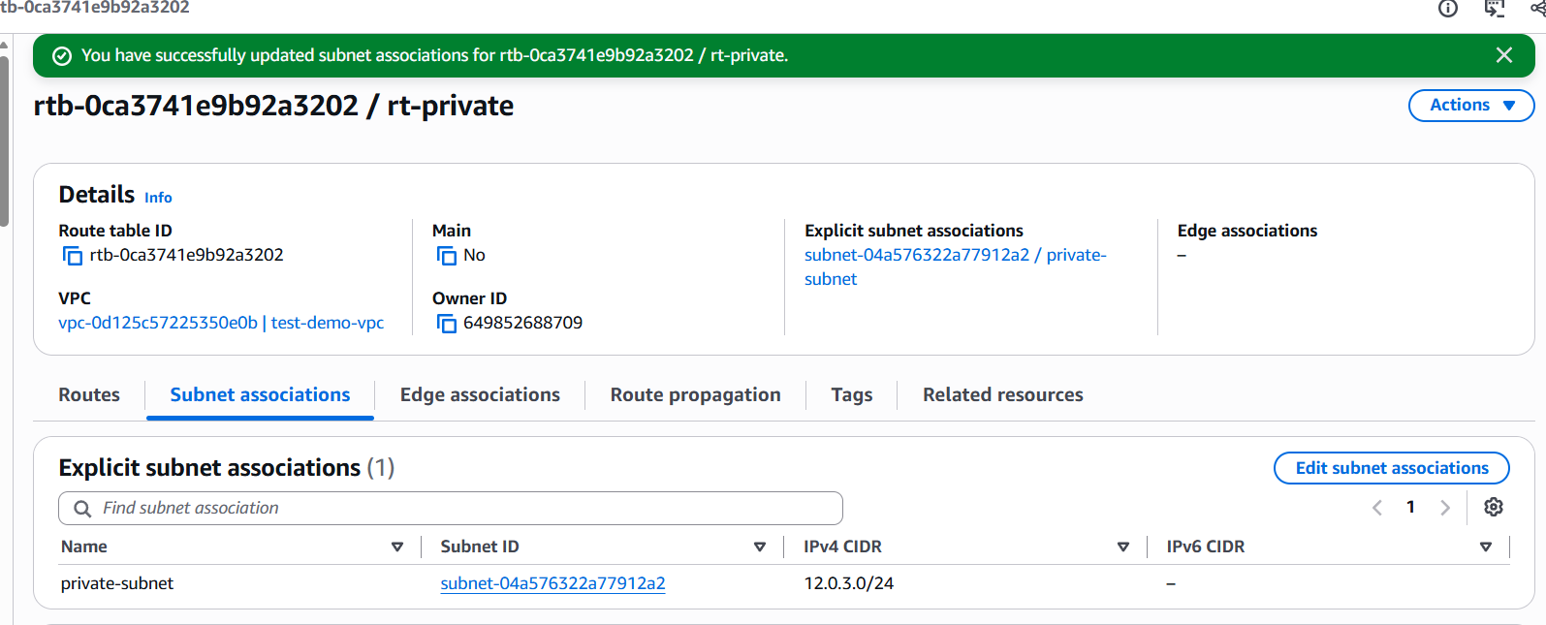

In the next step we need to create the EC2 Instances for the subnets and the network setting should loo like below photos and after that click on the launch instance button here we hab=ve created the instance for our public subnet :
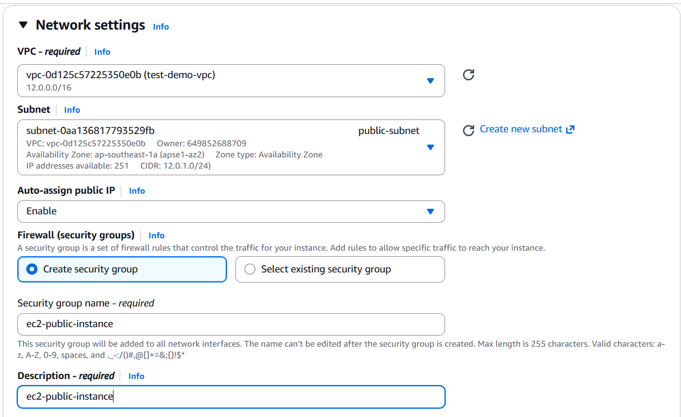
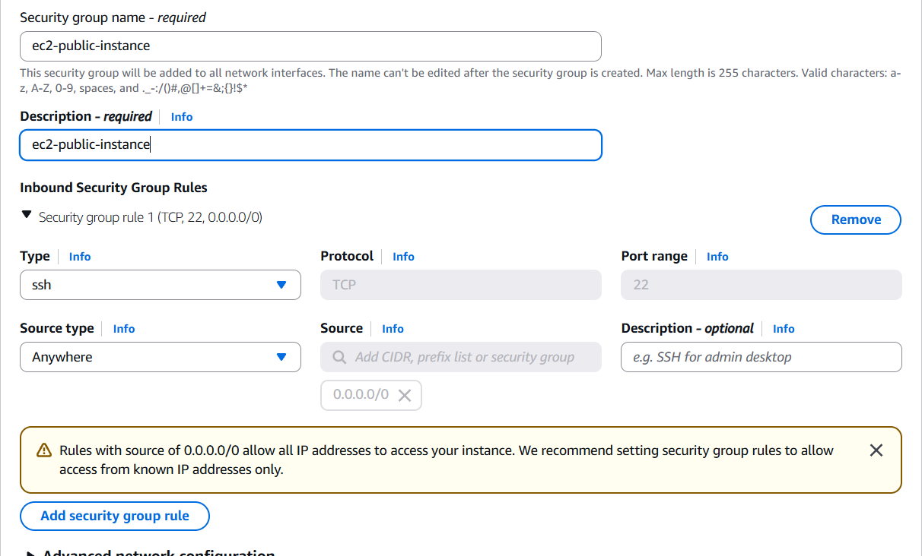

We should jump into the another region lets say mumbay and create the VPC as we created in the singapore region and also create the subnet :
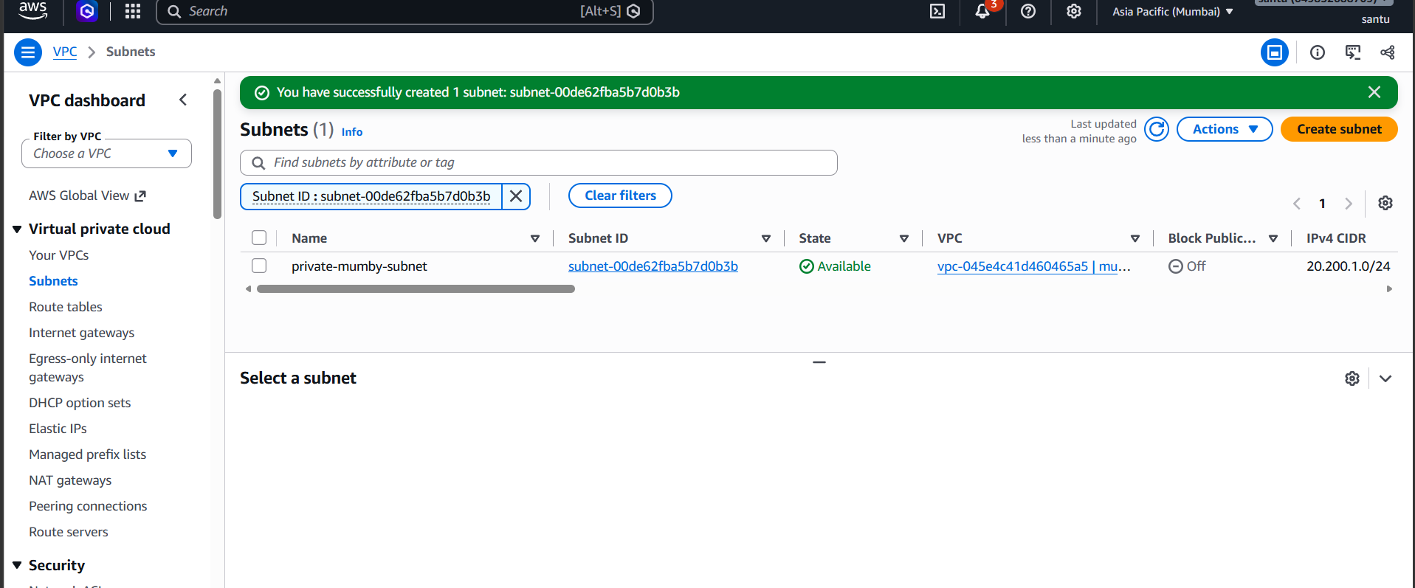

After this we need to peer the vpc so for ths we need to go for the peering connections click on create peering connection and name the peering connection selecte the VPC for which you want to connect the peering and in VPC ID enter VPC ID of singapore which we have created firstly:
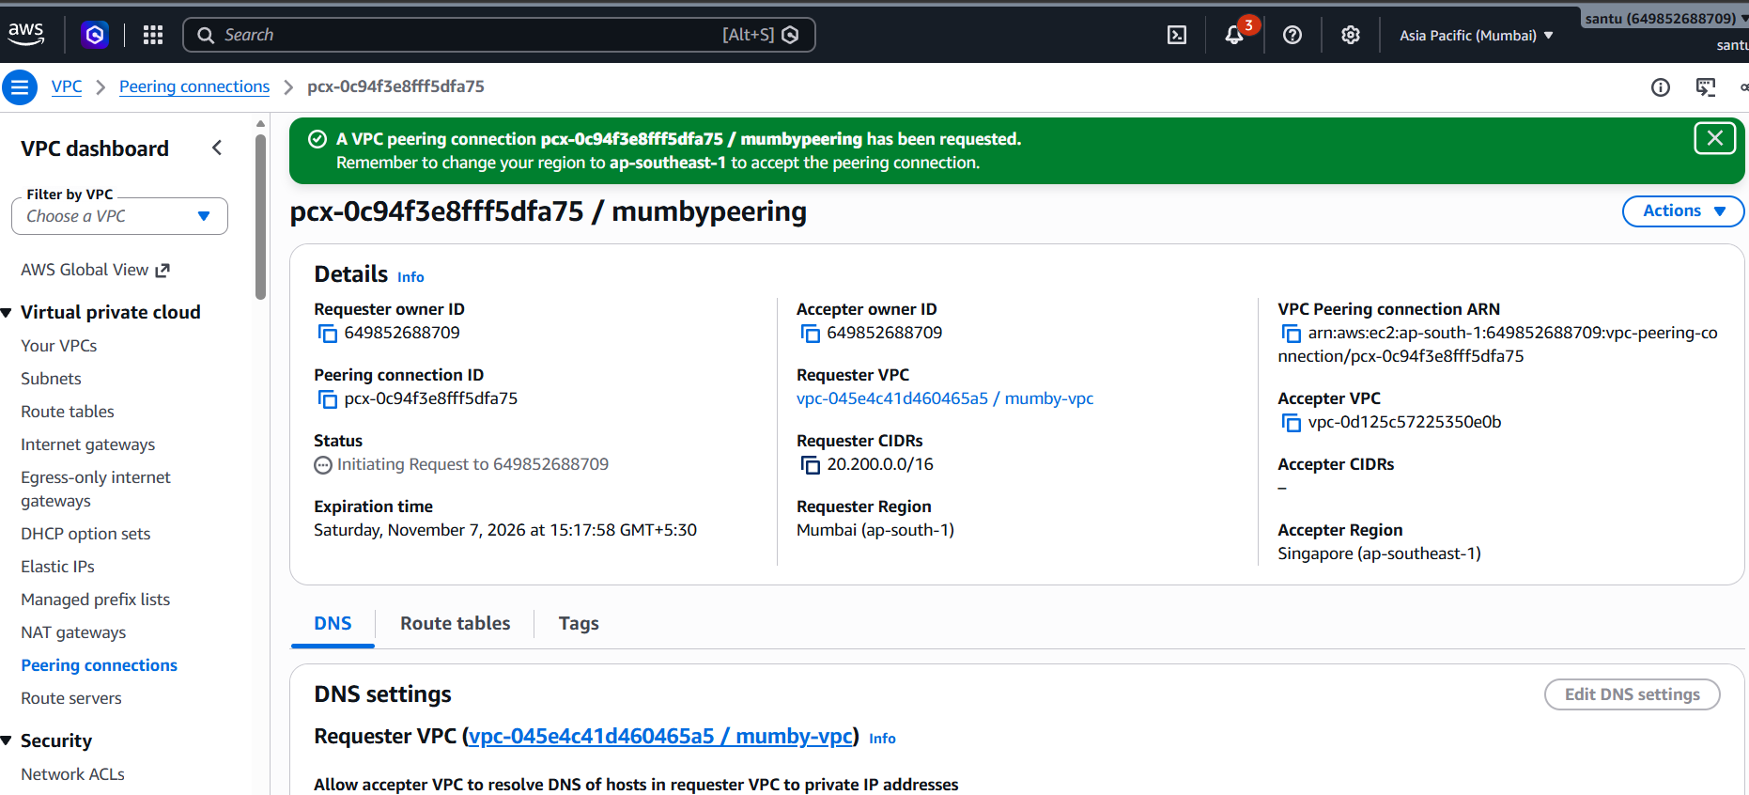
After the create the route table and add the peering connection to the subnet :
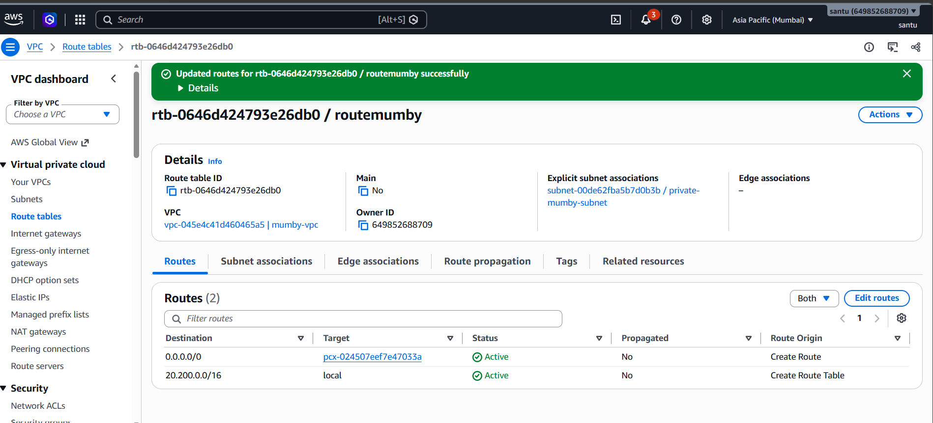
After this we need to connect to the bastion server for that open the mobaxterm and connect to the bastionsingapore instance:
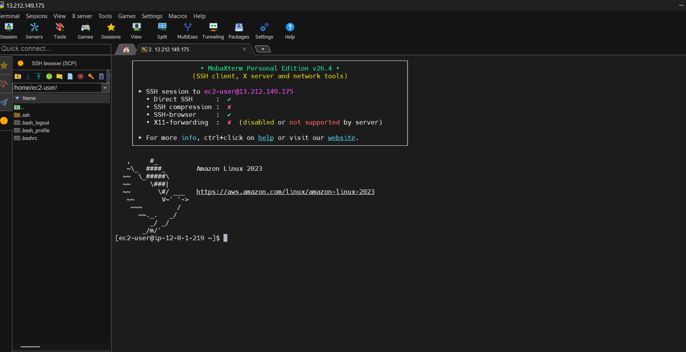
After this we need to connect to the datebase for that click on the upload button and upload the firstdatabase file :
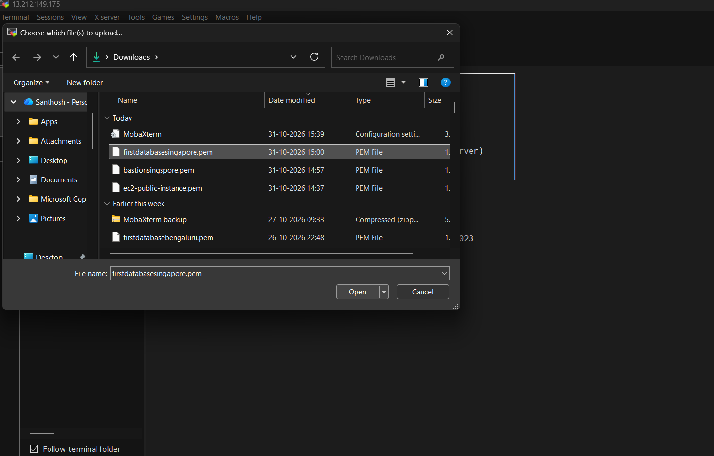
After we need to connect to the database so for that go to the AWS console and click on the firstdatabase and click on connect you will see the ssh id copie that ssh id and in the mobaxterm file past that ssh ID befor that we nned to pass the commad as
chmod 400 firstdatabasesingapore.pem
and then past the ssh ID :
ssh -i "firstdatabasesingapore.pem" ec2-user@12.0.3.122
the terminal will look like :
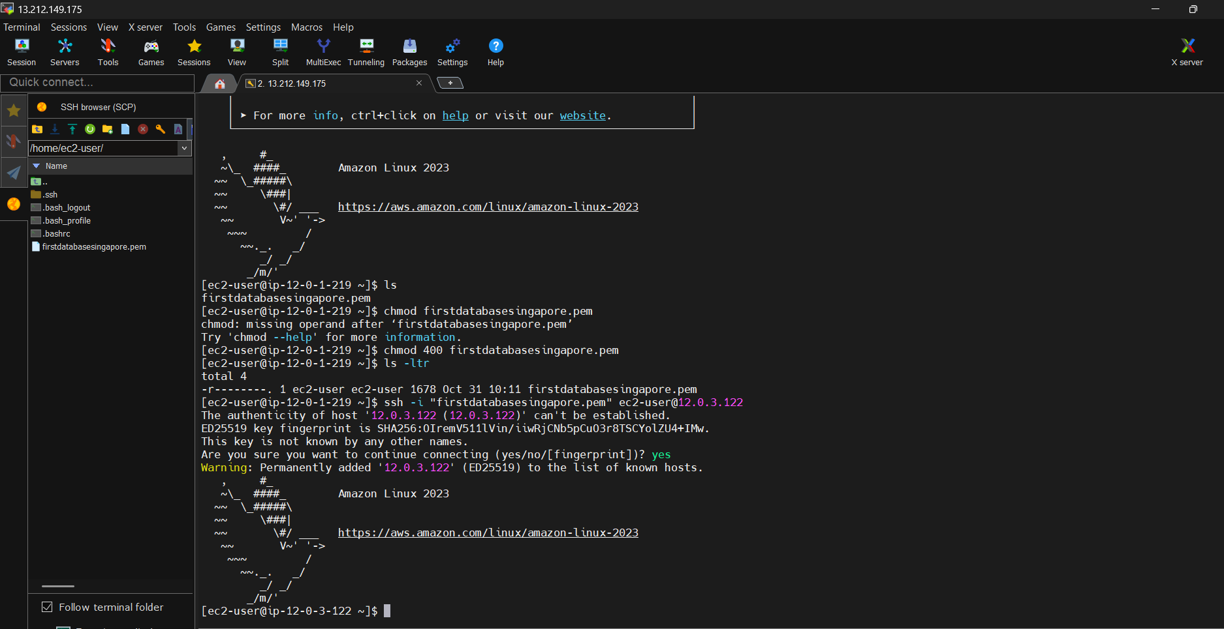
And then we need to connect to the another region to so for that go to the another region in the AWS console and create the instance named as databasemumby and now go to the mobaxterm terminal and upload the pirivate key-pair to the terminal and login to the instance by manually , first type
vi databasemumby.pem
and then open the private key-pair and copy past the whole thing into the terminal and the escape and type the command :
:wq!
Then the terminal will look like :
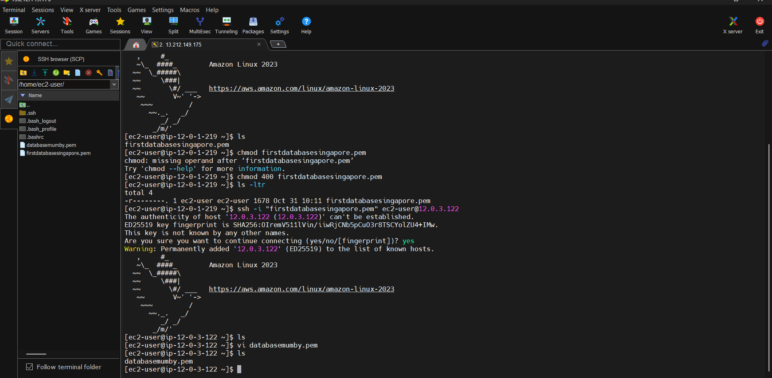
For acessing the permission for the key-pair type the command as :
chmod 400 databasemumby.pem
and then go to the AWS console and connect to the databasemumby to get the ssh ID copy the ssh ID and go to the mobaxterm Terminal and in the terminal type the command as :
sudo ssh -i "databasemumby.pem" ec2-user@20.200.1.164
now we are successfully connect to the database of the mumby region :


